The Crown Hotel Venue Guide

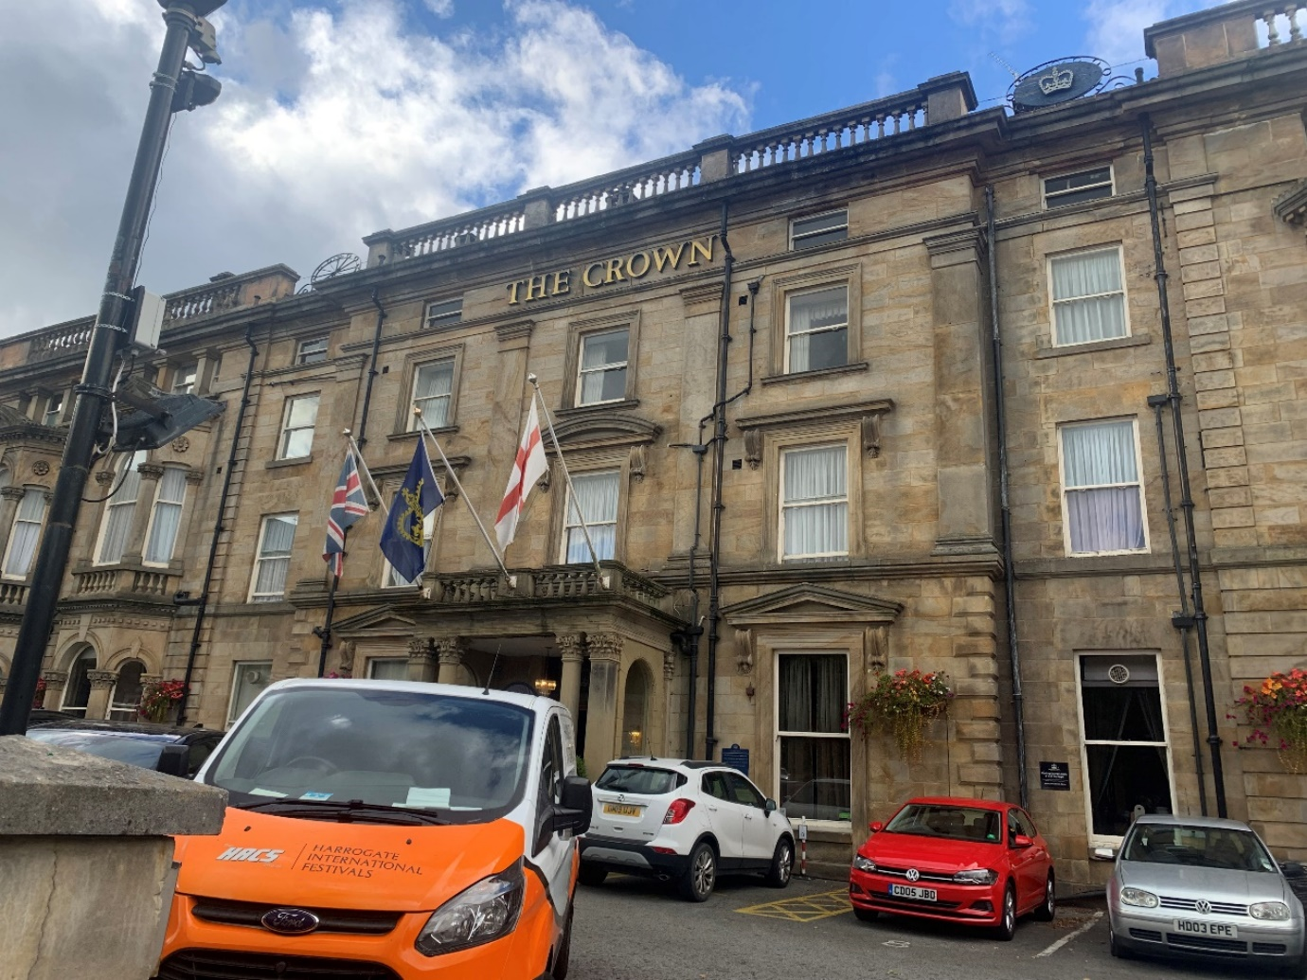
The Crown Hotel is located close to Valley Gardens, overlooking Montpellier Roundabout.
Full address: The Crown Hotel, Crown Place, Harrogate, North Yorkshire HG1 2RZ, United Kingdom
There is step-free access to each of the rooms in this venue.
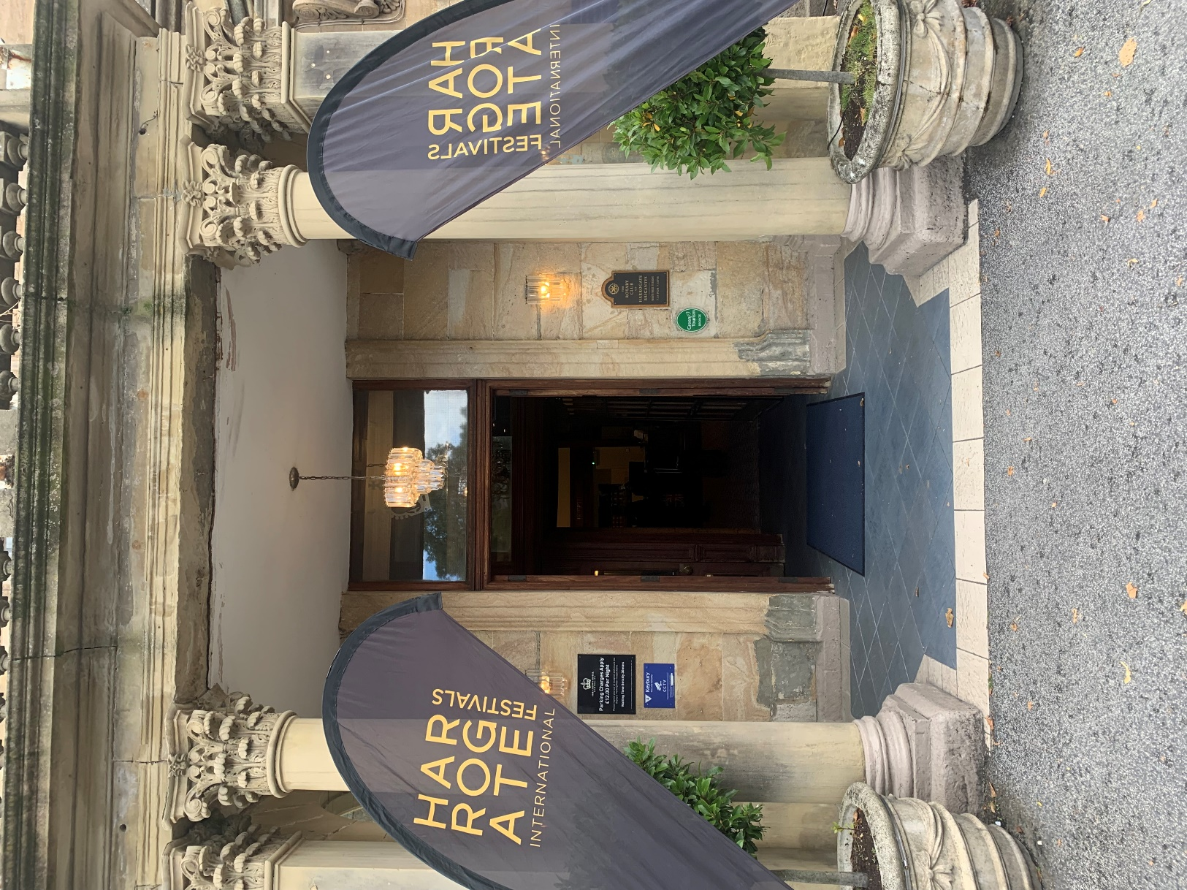
The entrance to the Crown Hotel will typically have Harrogate International Festivals flags outside to indicate we are running an event here. Inside the door to the left a standard door, in the centre a revolving door and to the right is an accessible door which is button operated, suitable for guests using mobility aids.

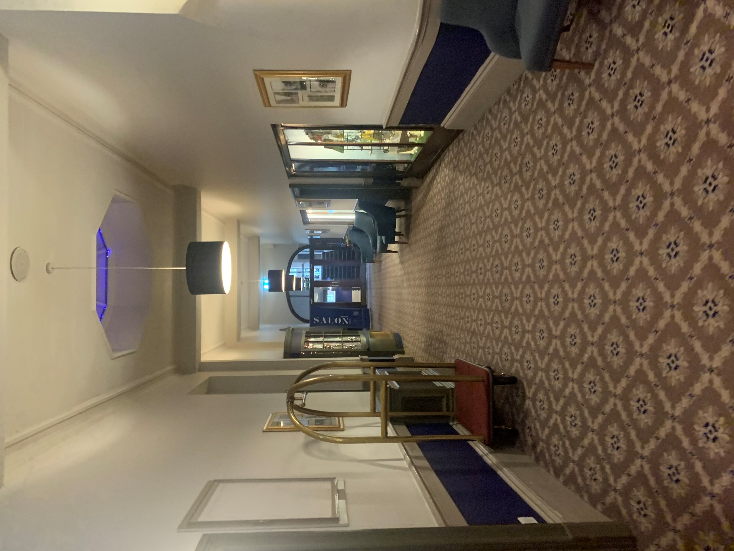
Once you have entered the lobby, as you approach the reception desk, if you turn right you’ll see this corridor which leads to the Victoria Suite where the majority of our events are hosted including Berwins Salon North and Raworths Harrogate Literature Festival. The Gentleman’s toilets are the last door on the left along this corridor.
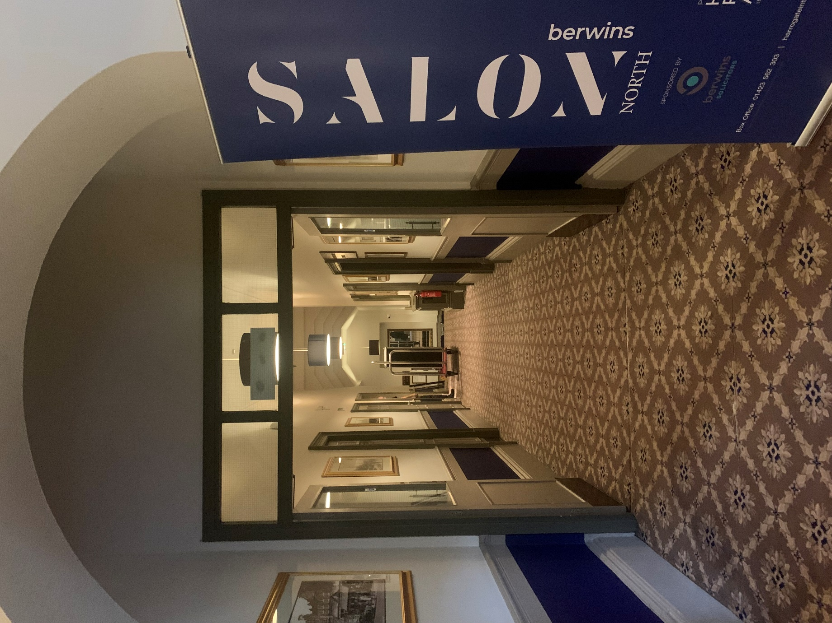
Turn left at the end of the previous corridor and proceed along the corridor to reach the Victoria Suite. At the end of this corridor is 6 steps with handrails either side. There is an access lift to the left before you reach the steps. Along this corridor on the left are the ladies toilets and an accessible toilet.

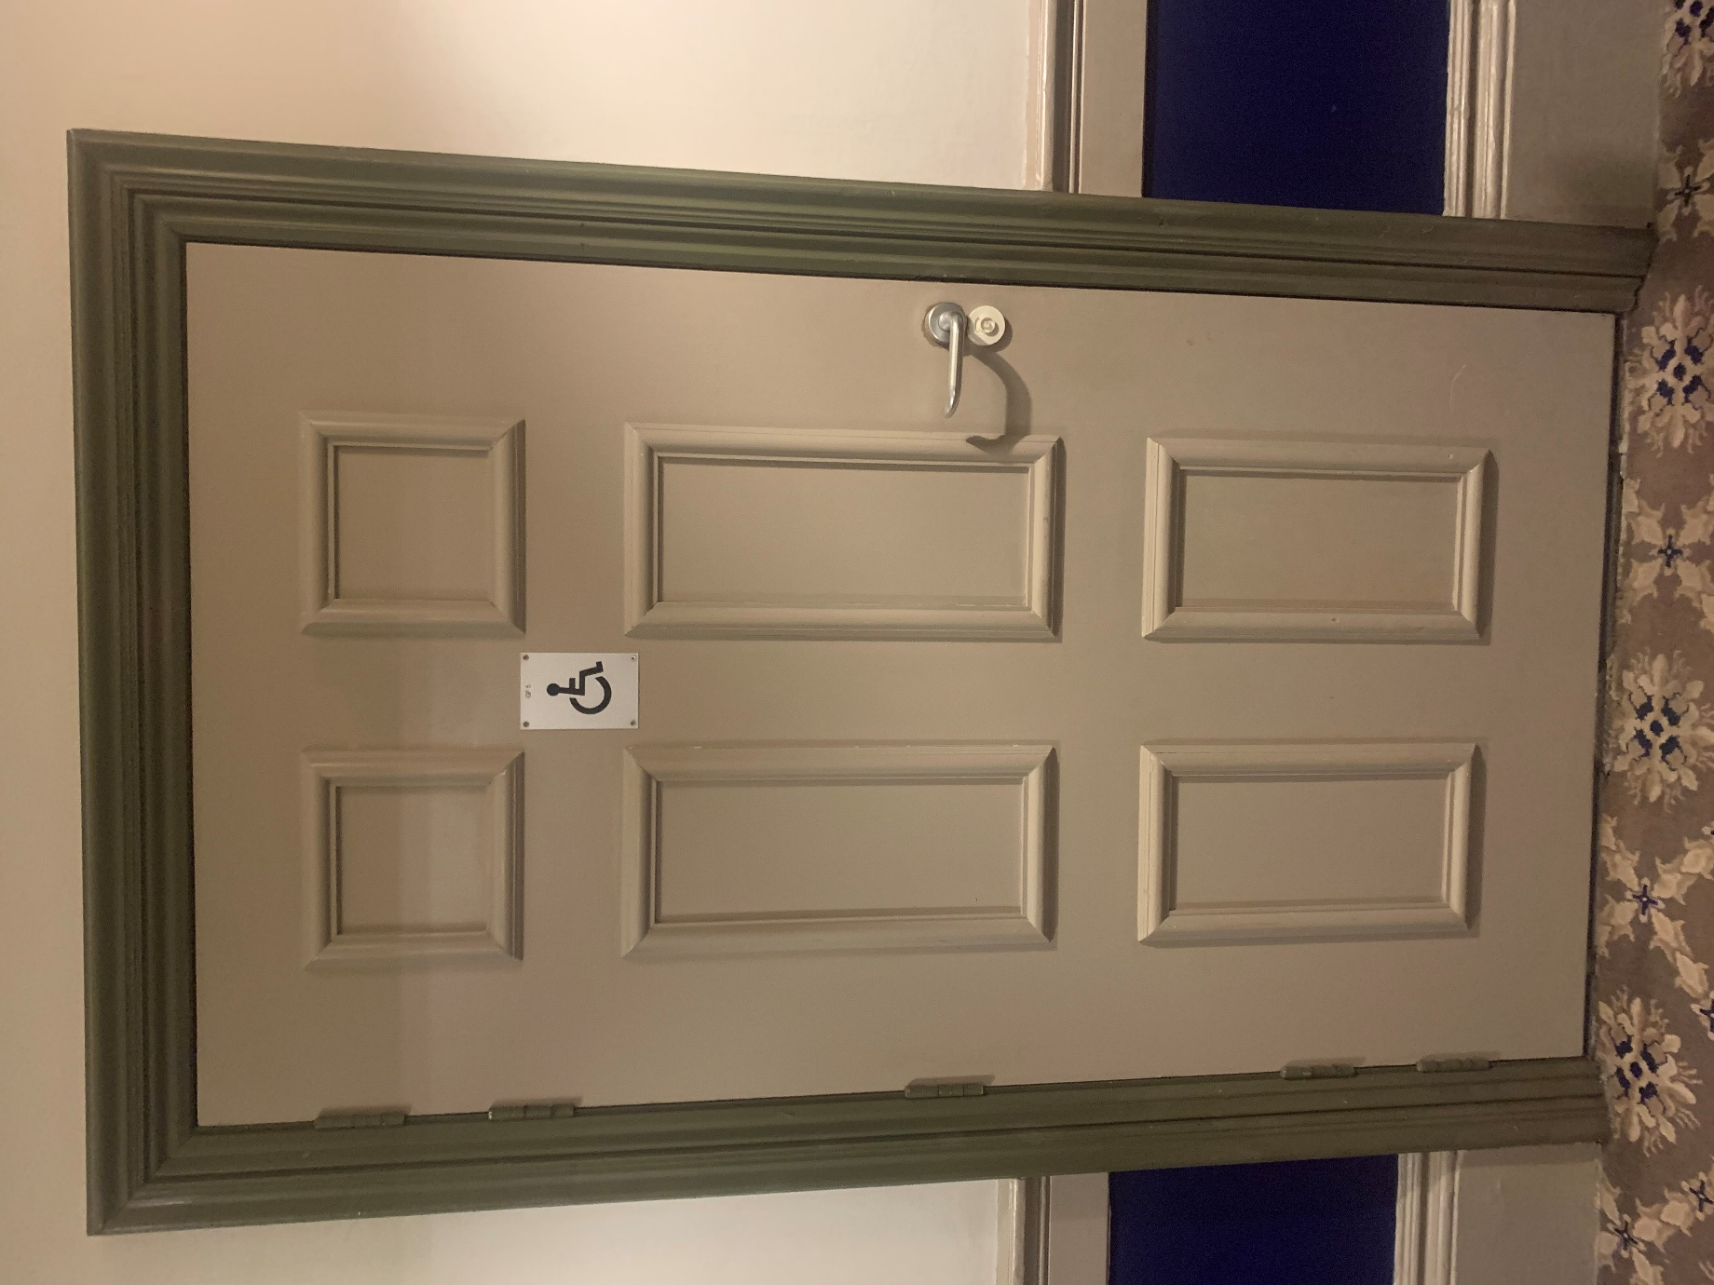
The accessible toilet can be accessed without a RADAR NKS key. Below the handle will have a red slot to indicate if the toilet is already engaged.

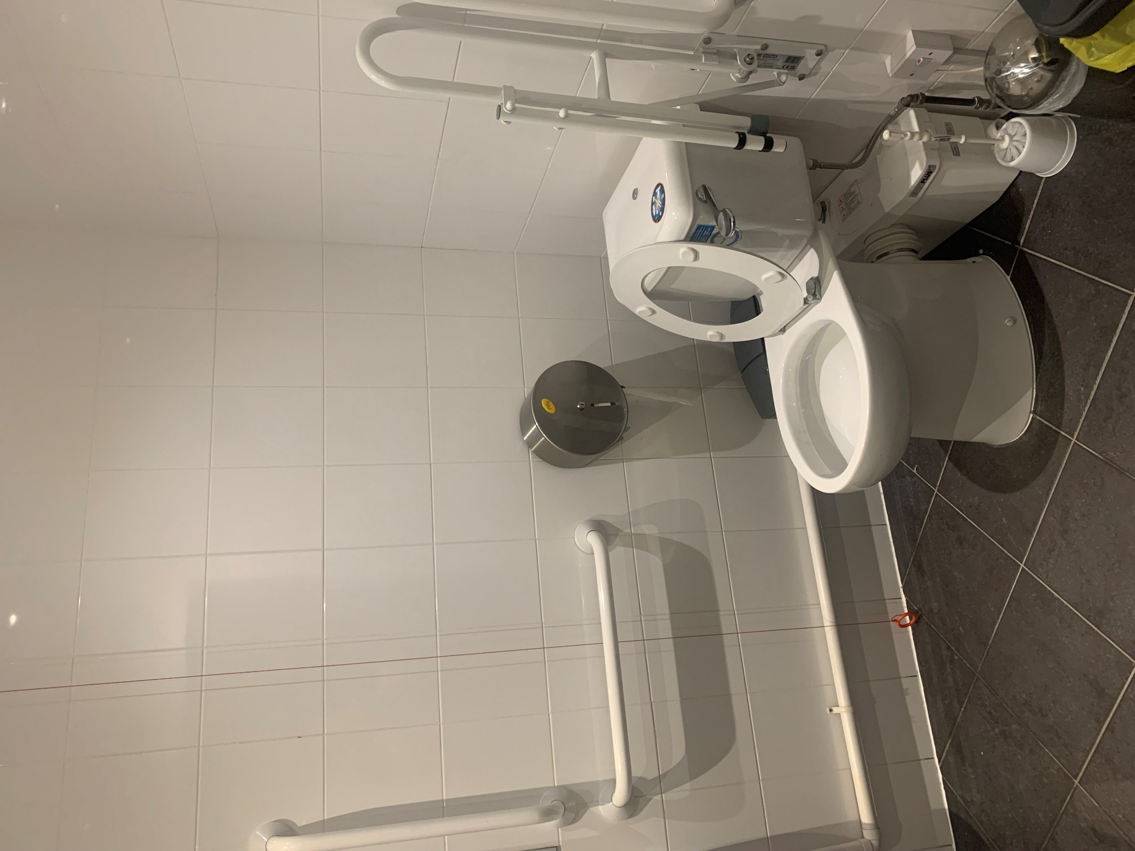
This accessible toilet is fitted with handrails and a red cord which will raise the alarm for assistance in the event of an emergency.

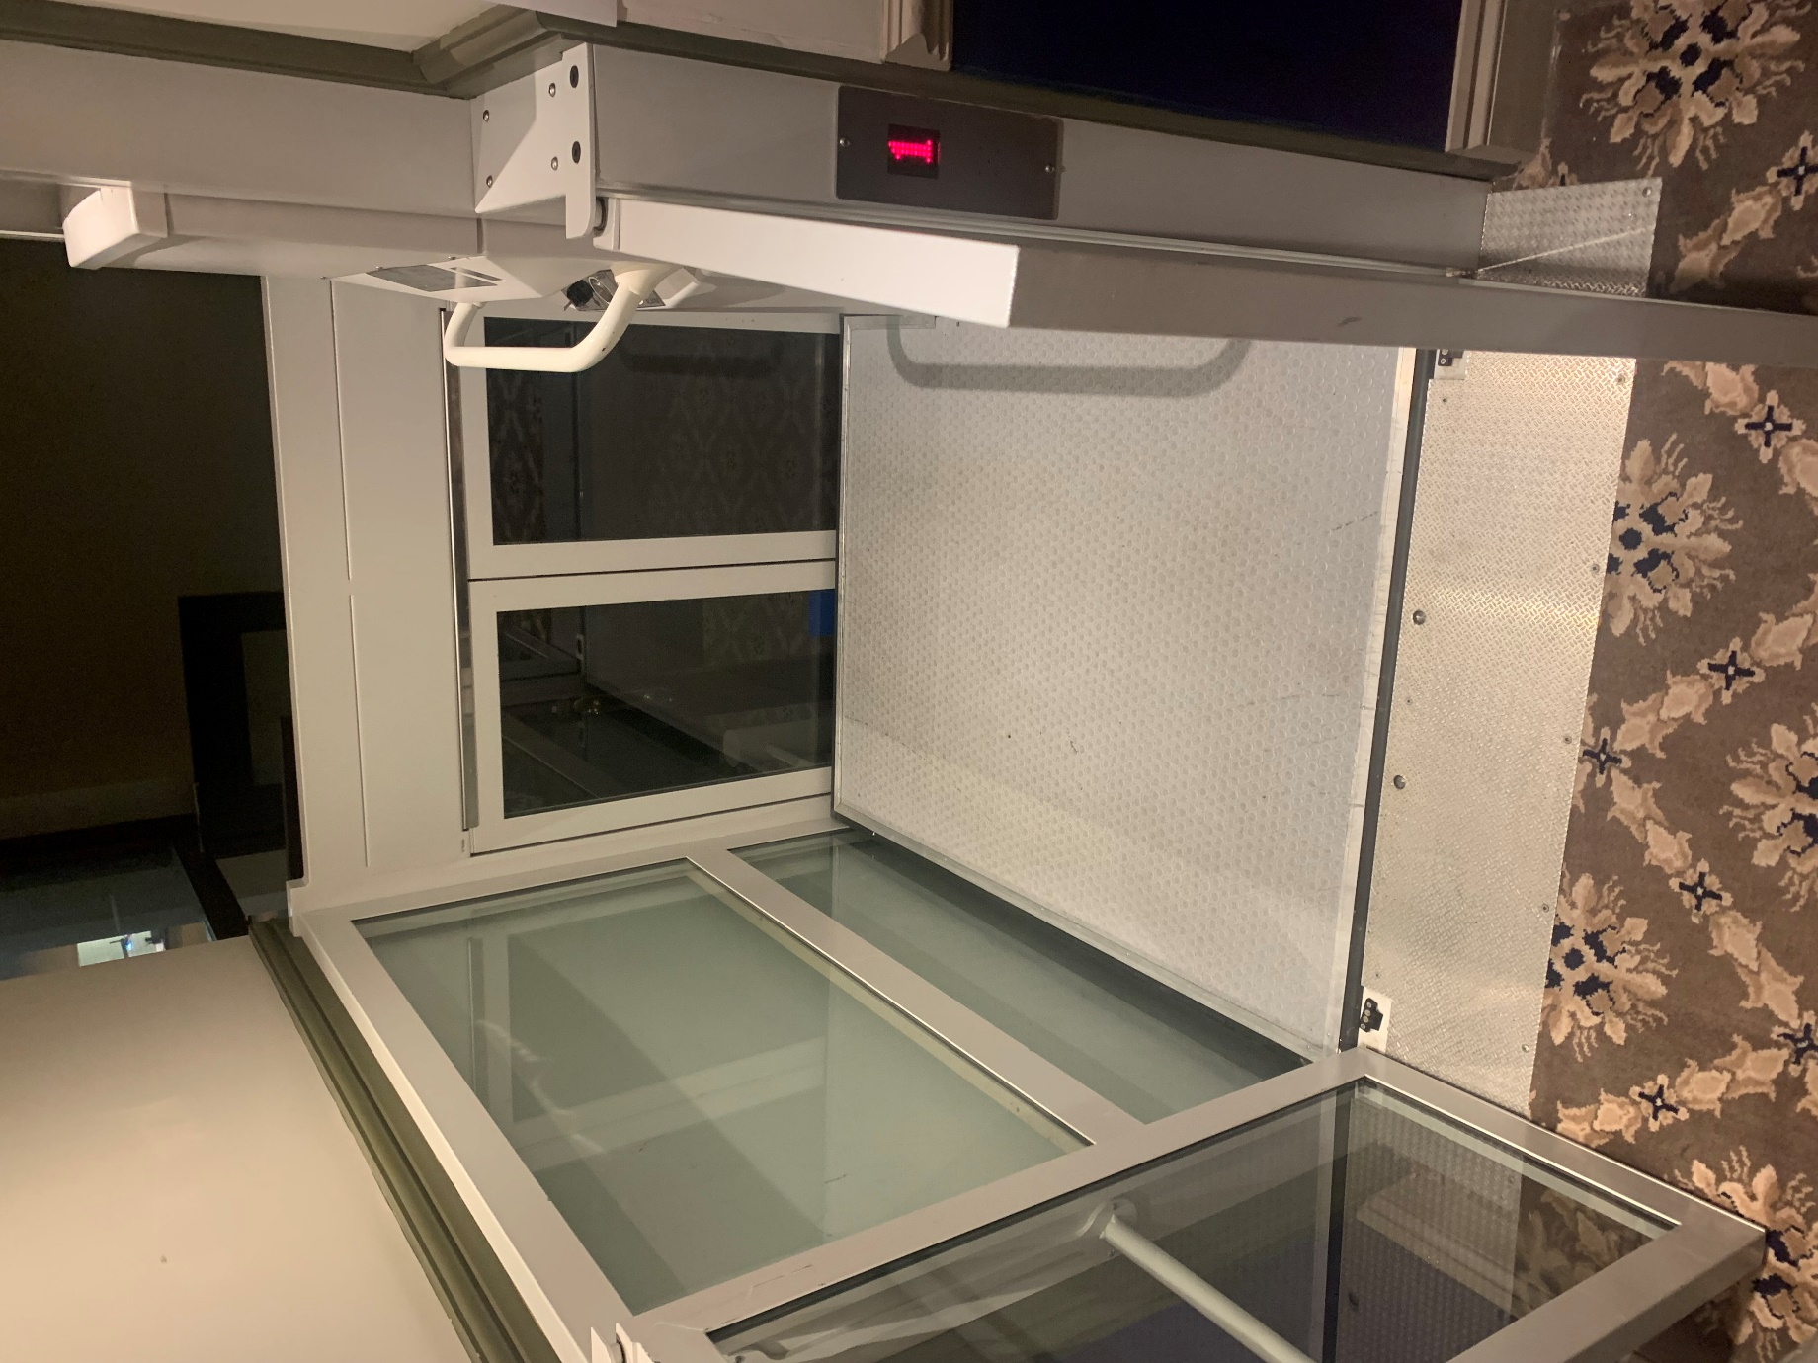
The doors to the lift open out towards guests. Please ensure these are shut fully before attempting to move down a floor.

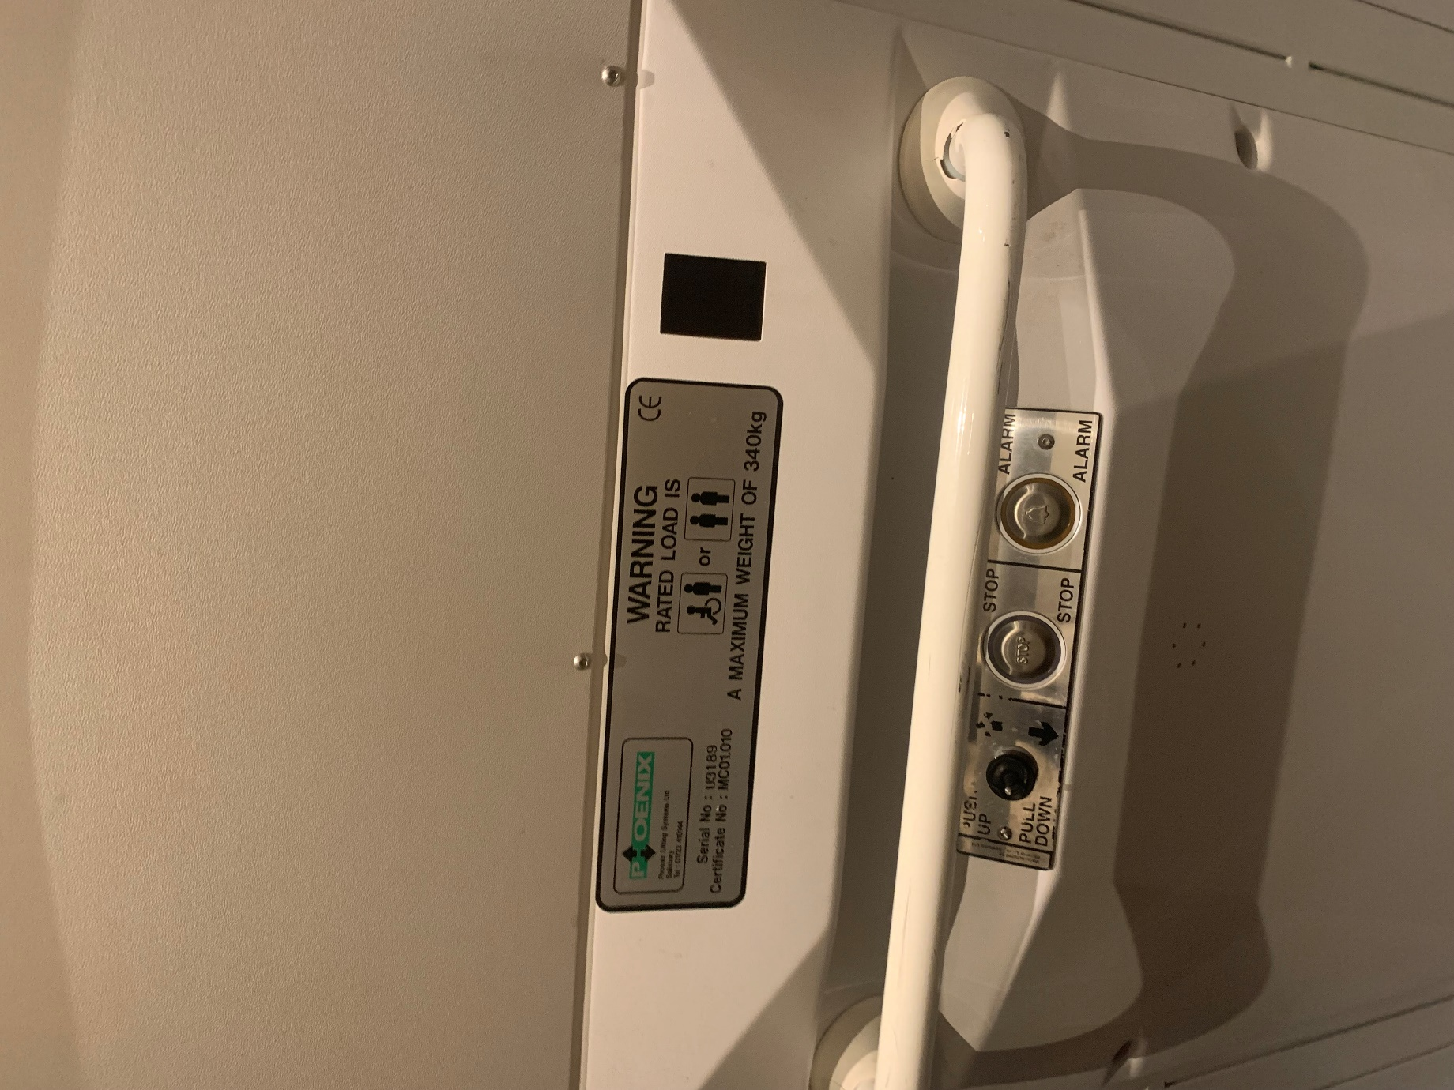
There is a switches to move the lift up or down, stop the lift and raise an alarm if assistance is required.

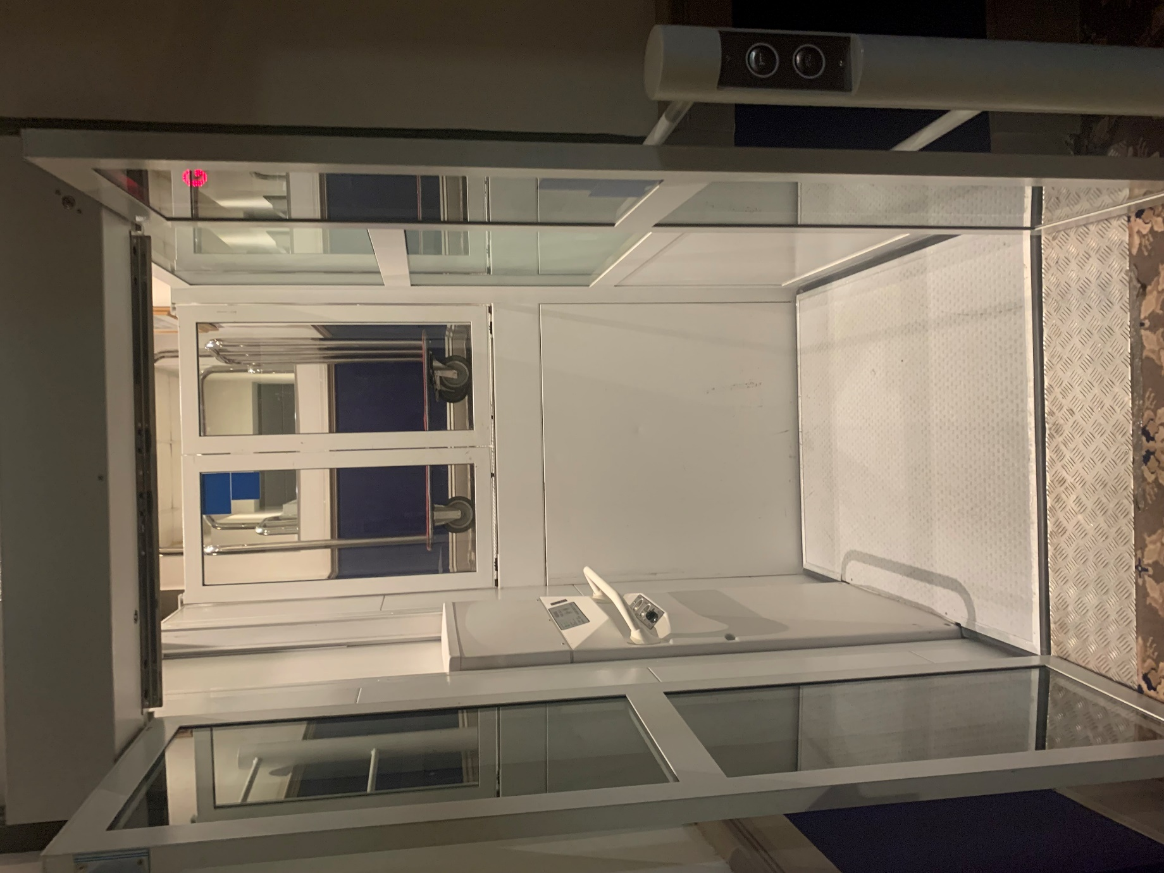
You can exit / enter the lift beside the entrance to the Victoria Suite where our friendly volunteers will check your tickets. They will wear black t-shirts with white writing indicating that they are volunteers of the Festival.

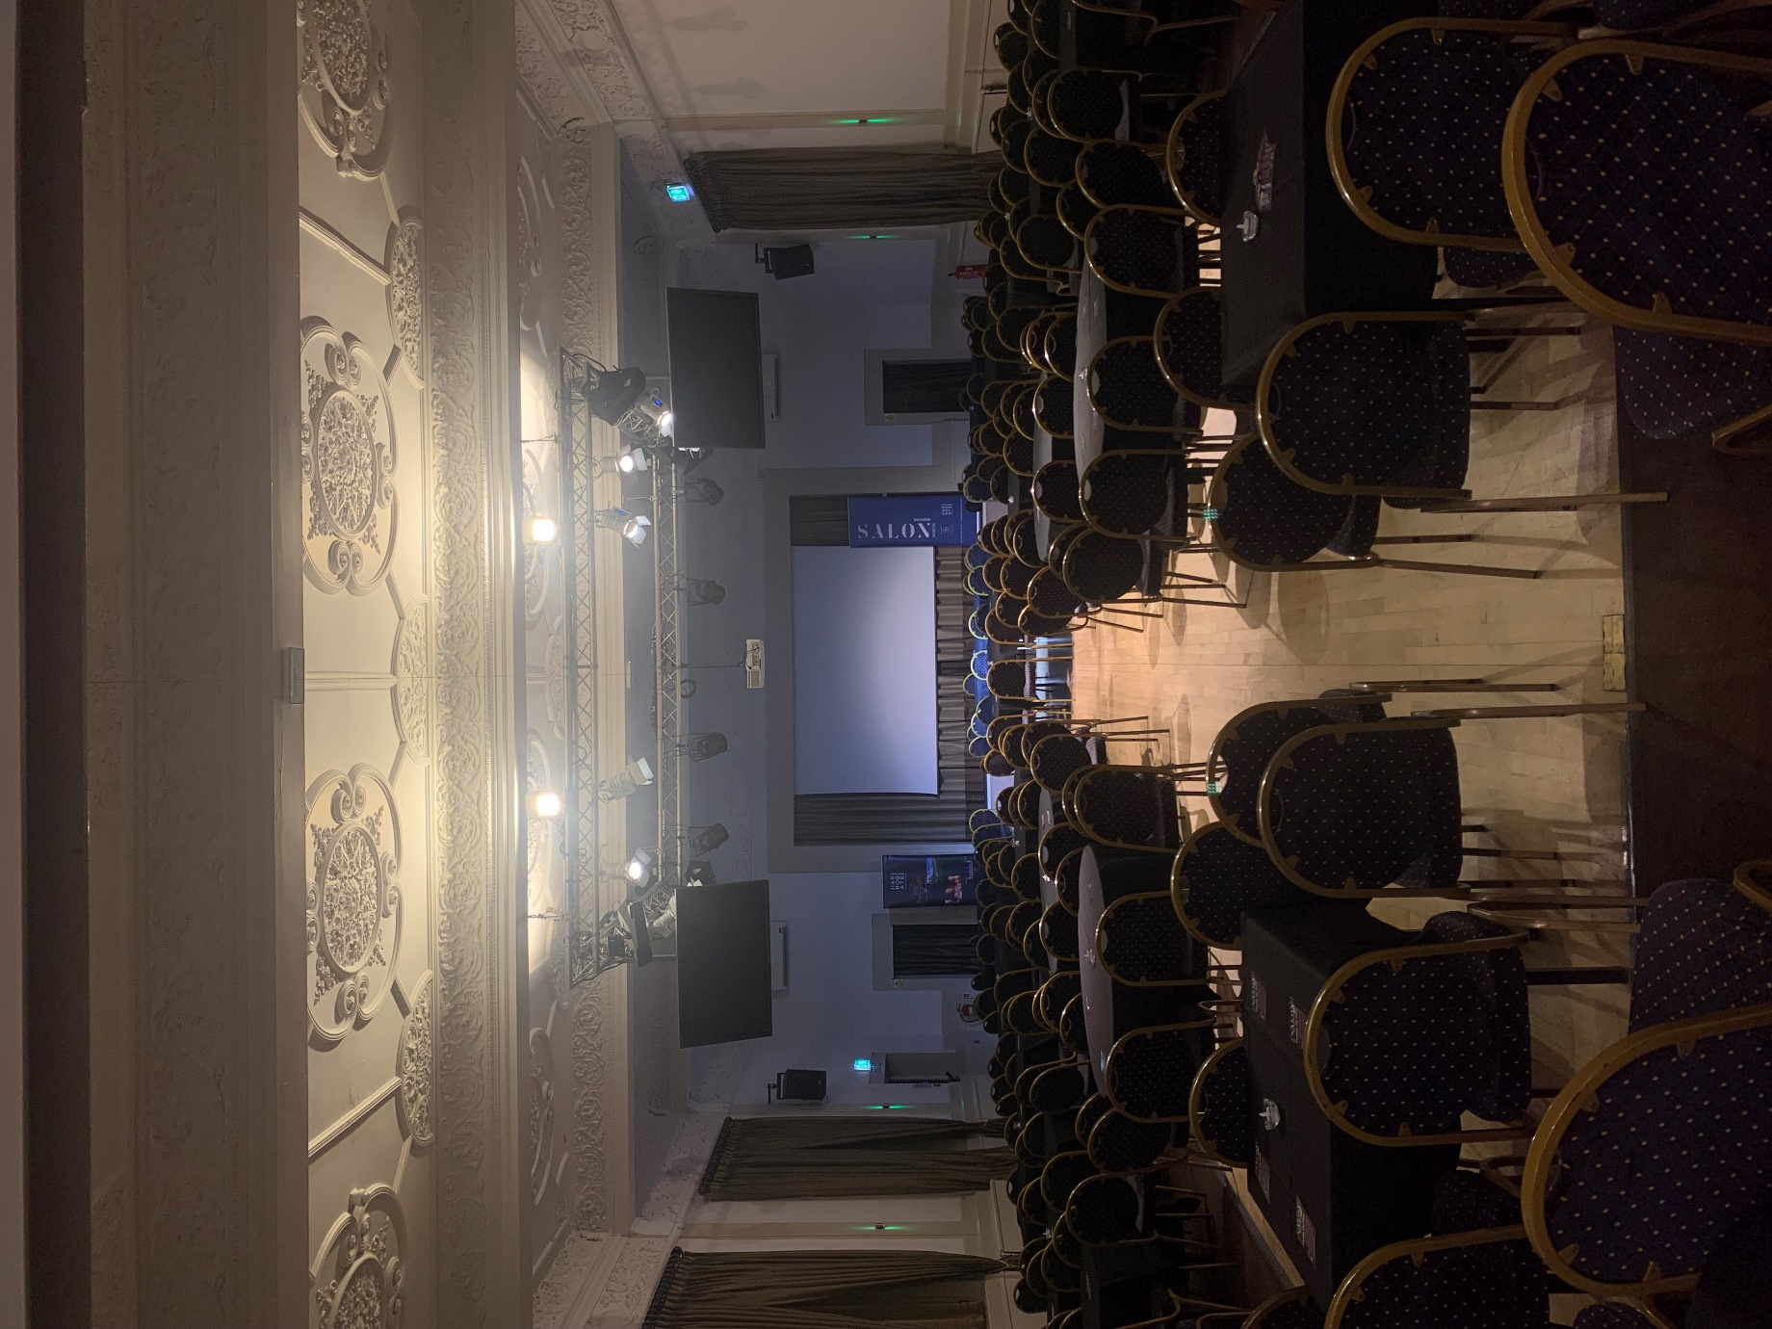
The venue from the back. This layout is called caberet seating and is typically used for our Berwins Salon North events. Please notify Box Office ahead of time if you require a wheelchair accessible seat or any other adjustments.
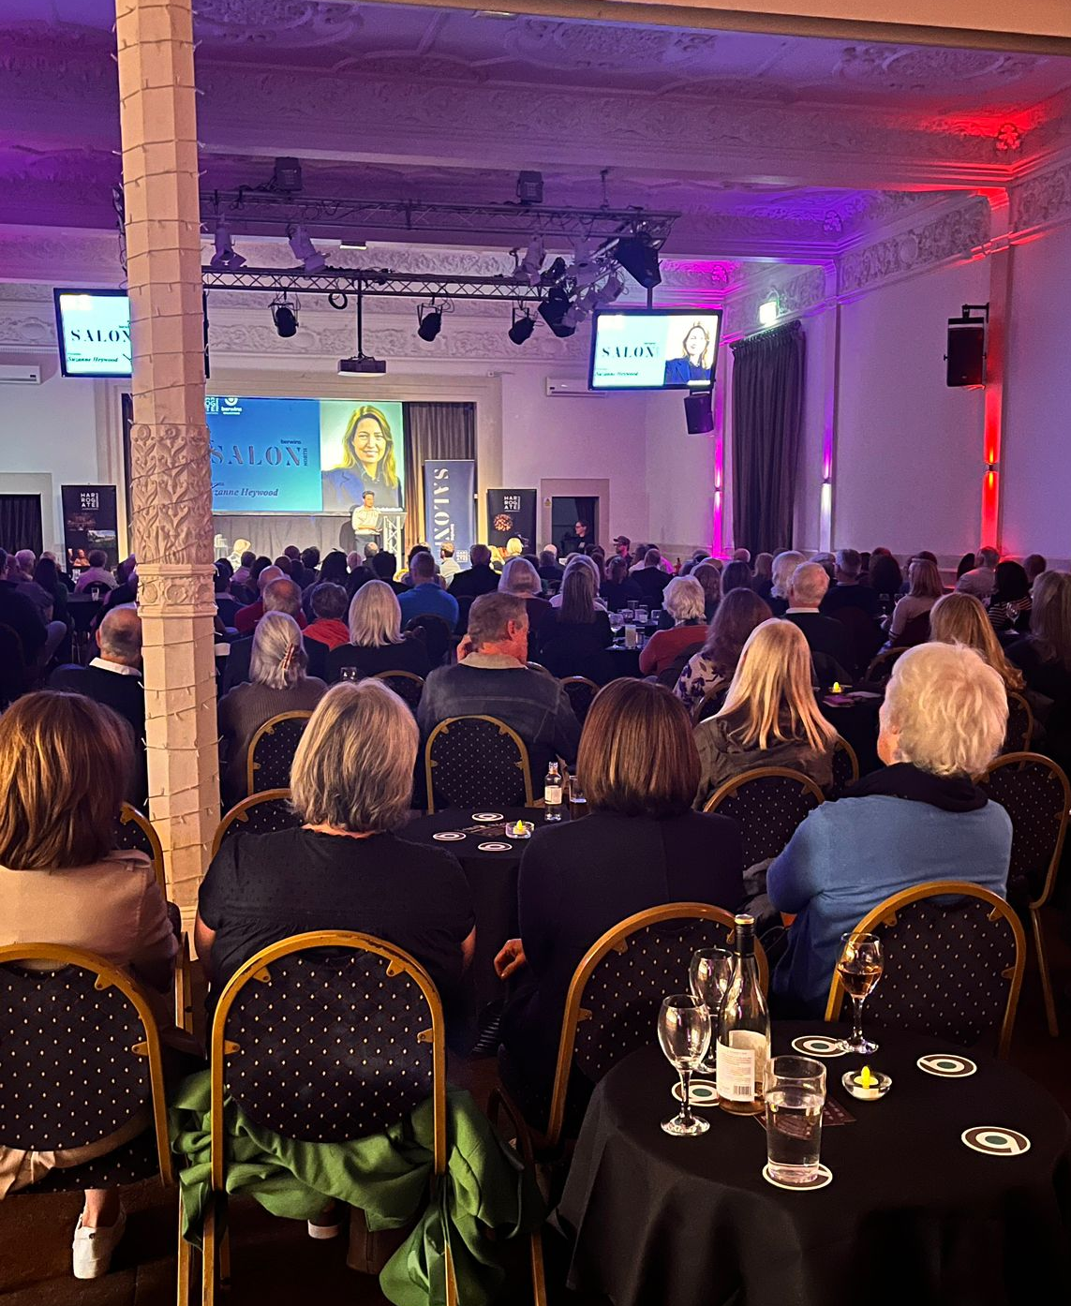
Tables for Berwins Salon North events will have coasters for drinks and an LED tealight (there is no open flame). There may be overhead lighting to illuminate speakers onstage and some warm lighting throughout the room. Speakers may also bring their own PowerPoint slides.
Our speakers will have microphones to ensure they can be heard throughout the venue.

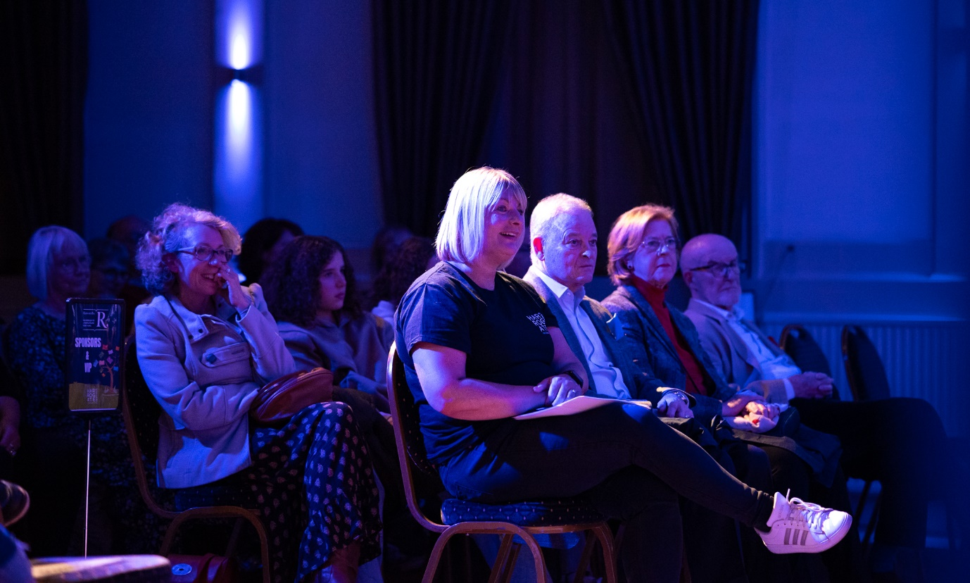
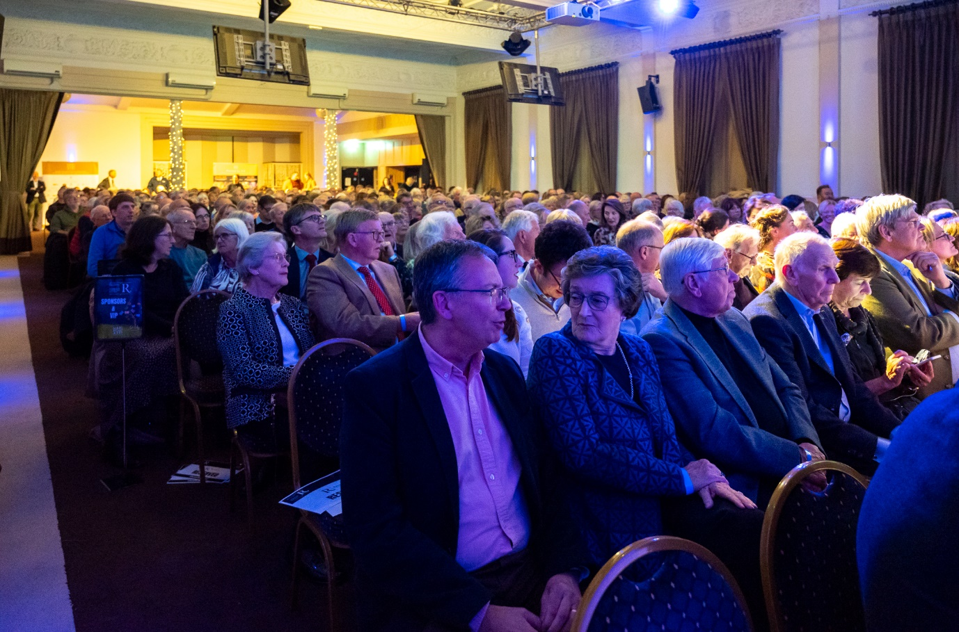
For other events, seating will be arranged in rows with an aisle down the middle. Please notify Box Office ahead of time if you require a wheelchair accessible seat or any other adjustments.

