Christ Church Venue Guide

Full address: Christ Church, Church Square, Harrogate HG1 4SW

Located on The Stray in High Harrogate, Christ Church has nearby free on-street parking as well as disc parking.

The main church access point has 3 steps.
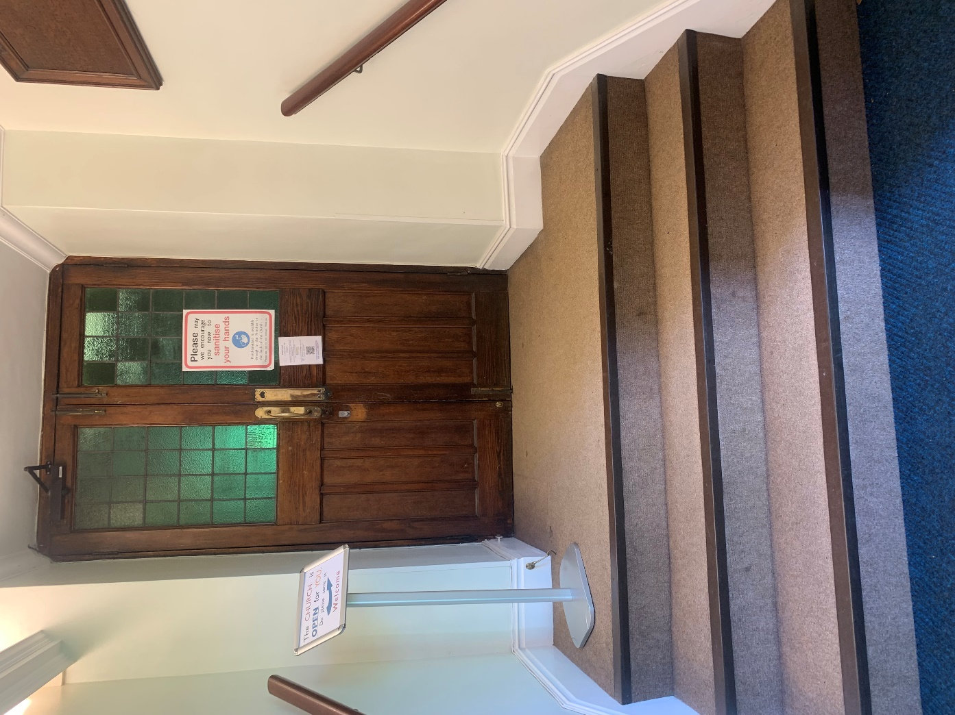

The church can also be accessed through the Parish Centre which allows for step free access up a ramp. 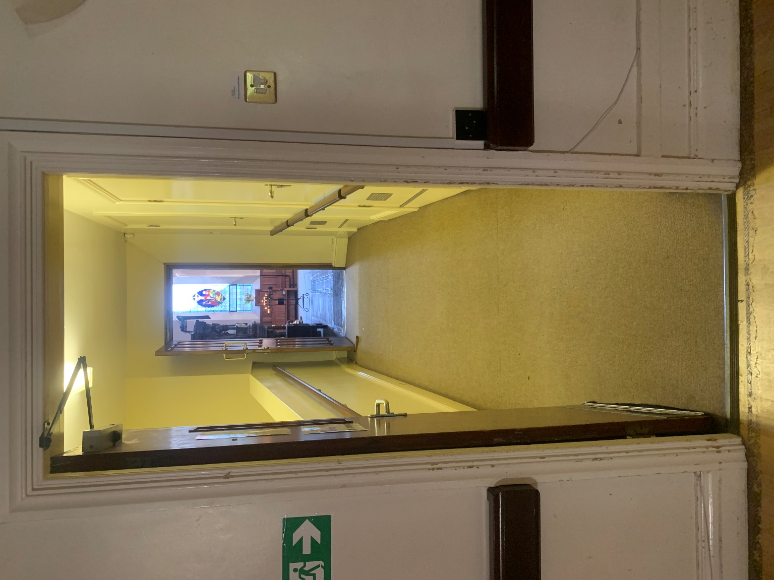

This will bring you out at the front, near the altar where there is wheelchair accessible area for seating. This area is newly paved so it is level and individual seats can be placed where needed.

Wheelchair seating area pictured below:

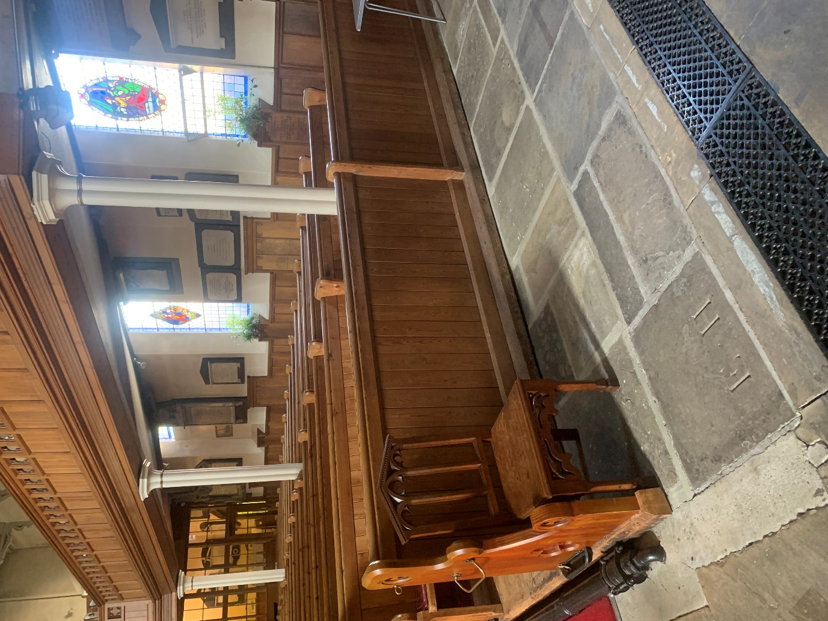

The disabled toilet is found in the parish centre, completely step free and does not require a radar key to access.

