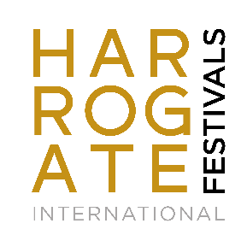
SUmmer Festival Assistant
Opportunity for individuals interested in gaining experience in the arts and event management
The Festival Assistant role offers valuable professional experience for those interested in developing a career in event management, arts administration, leisure and tourism, entertainment management and hospitality.

Salary:
Hourly rate of pay, in line with the current National Living Wage.

Dates: May – July 2026
- Full time (5-6 days, approx. 40hrs per week)

Applications Open: Friday 16 January 2026
Deadline for Applications: Monday 16 February 2026
Interviews: March 2026

Hosting internationally acclaimed artists and authors from all over the world, we can guarantee that your time spent in Harrogate will be action-packed. Many of our Festival Assistants have gone on to successful careers in related fields, our placements giving them the necessary skills required to place themselves ahead of the competition in terms of work experience.

In Summer 2026 we are looking for individuals to join the HIF Team throughout May, June and July. During this time, you will help us to deliver Harrogate Music Festival which runs throughout June and July, and our renowned Theakston Old Peculier Crime Writing Festival, as well as series of other exciting events including Berwins Salon North, other outdoor spectacles and Children’s Festival. Candidates should demonstrate an enthusiasm and interest in the arts, as well as event management and knowledge on content creation for social media.

This is a full-time role approximately 40 hours across 5-6 days per week. The general office hours are 9.30 to 5.30, Monday to Friday. However, as an events organisation, the hours/days of work at the Festivals often reflect the needs of events, therefore this will include long days working unsociable hours and will include evenings and weekends.
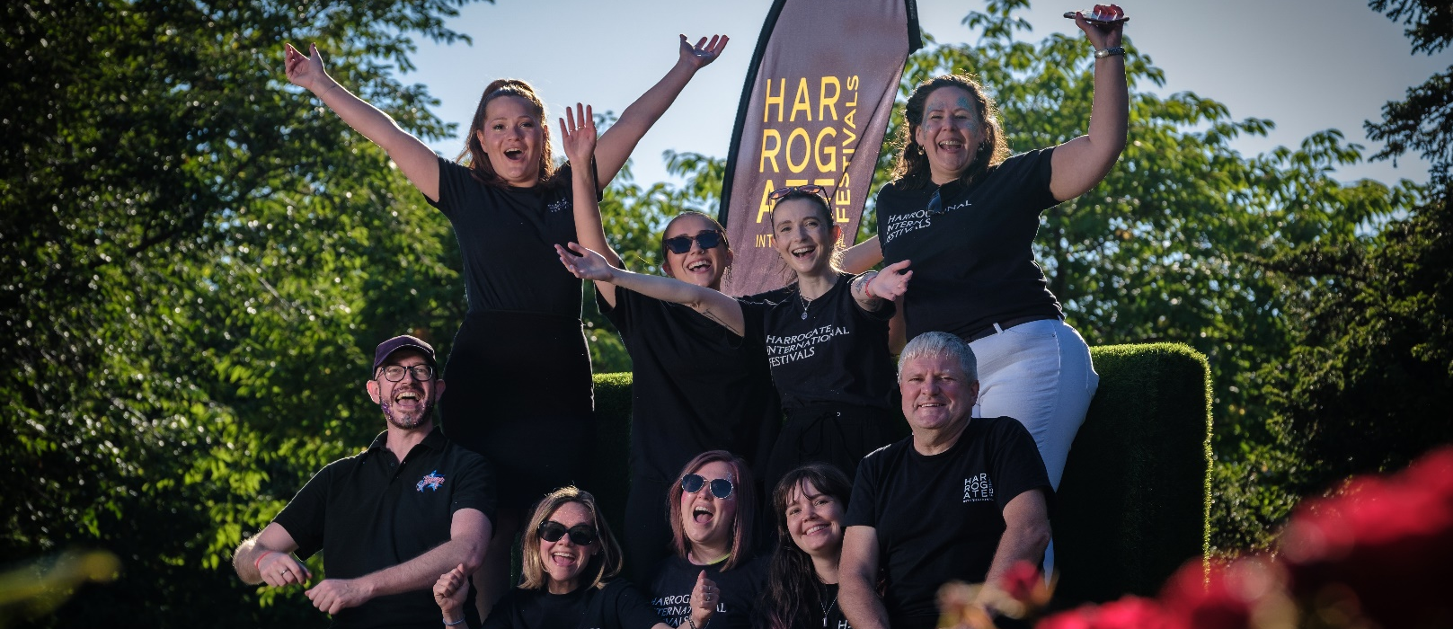

Personal Attributes:

- An interest in and enthusiasm for the arts
- Ability to communicate with people at all levels
- Good attention to detail
- Natural problem-solving ability
- Ability to use own initiative
- The willingness to work long hours
- Plenty of energy and ability to undertake strenuous tasks e.g. get ins/outs
- Practical experience of event management
- Box office and/or customer service experience
- Computer literacy
- The ability to support the team with social media content
- Driving licence and access to a vehicle (desirable)

Person specification:
Successful candidates will be enthusiastic about and committed to the Festivals and its audiences. They will be keen to learn and contribute to the work of the team. We look for people who are flexible, enthusiastic, and willing to try new things. It’s tiring, so you’ll need to be prepared for hard work, but the buzz of working on high quality events and welcoming audiences young and old alike will provide a unique level of satisfaction.

How to Apply:
Please send your CV and a covering letter, outlining your interest to info@harrogate-festival.org.uk.



Website: Facebook:
Harrogateinternationalfestivals.com @HarrogateInternationalFestivals



Twitter: Instagram:
@HarrogateFest @HarrogateFestivals

