The Old Swan Hotel Venue Guide

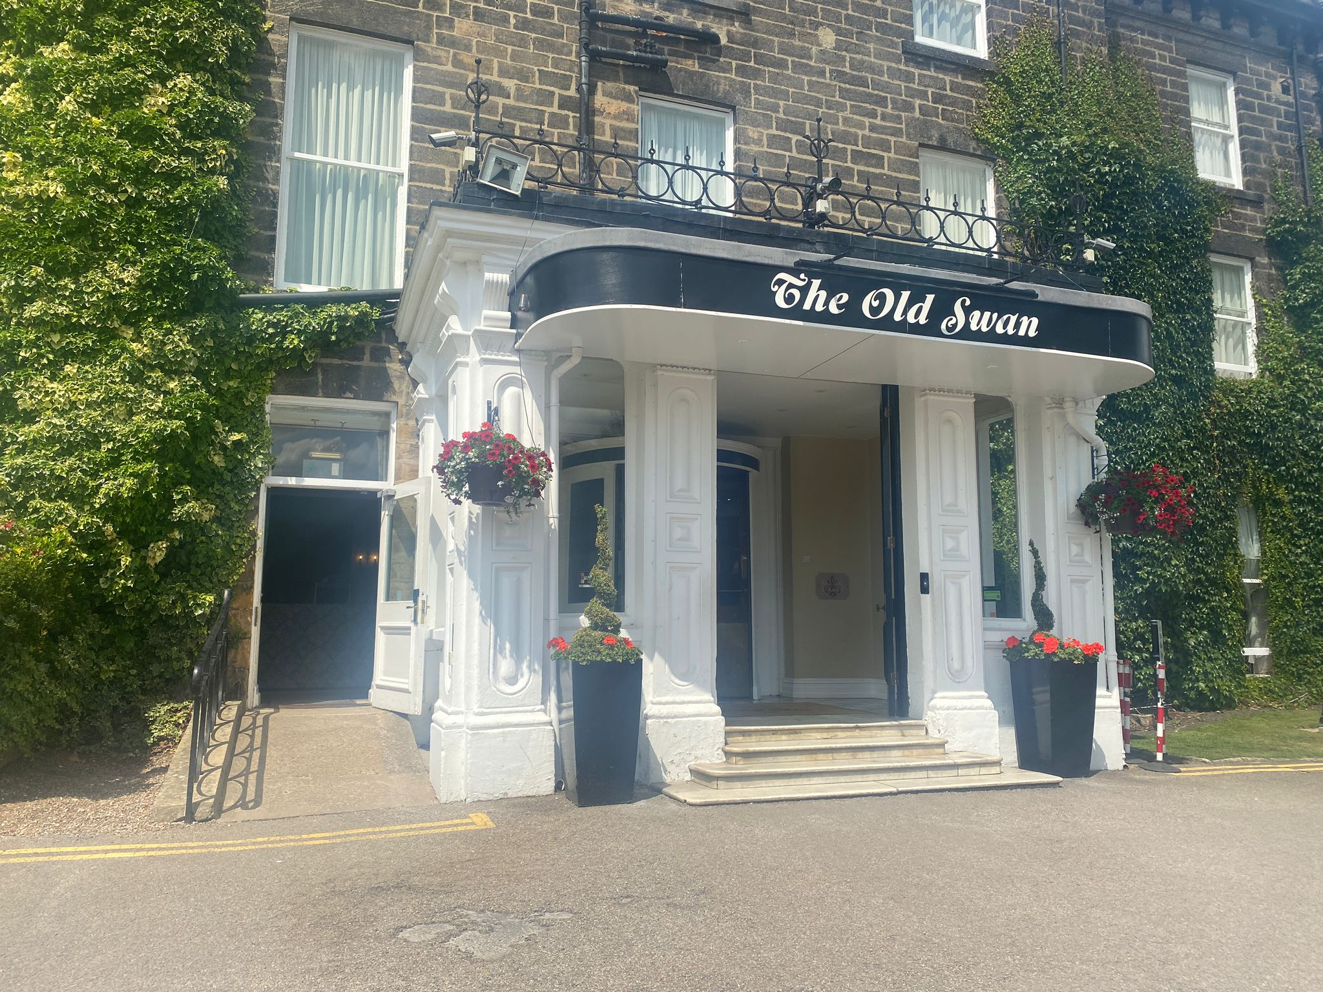

Full address: The Old Swan Hotel, Swan Road, Harrogate, North Yorkshire HG1 2SR, United Kingdom
There is step-free access to each of the rooms in this venue but to access some areas of the site, there is an incline.

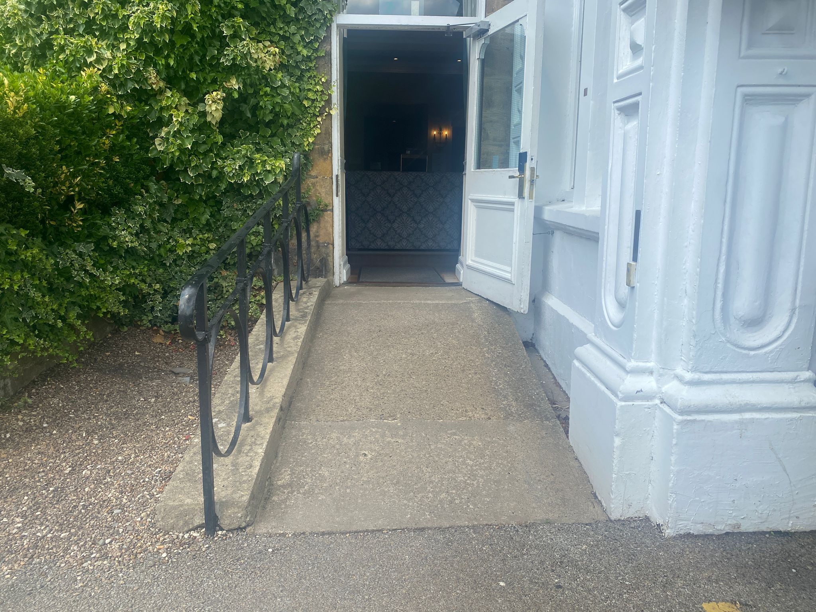

The entrance to the Old Swan Hotel will typically have Harrogate International Festivals flags outside to indicate we are running an event here. On the left side of the building is a ramp and doorway which can be used to enter the hotel’s main reception area. On the right are 4 steps up to a revolving door whereby guests can also access the hotel’s main reception area.

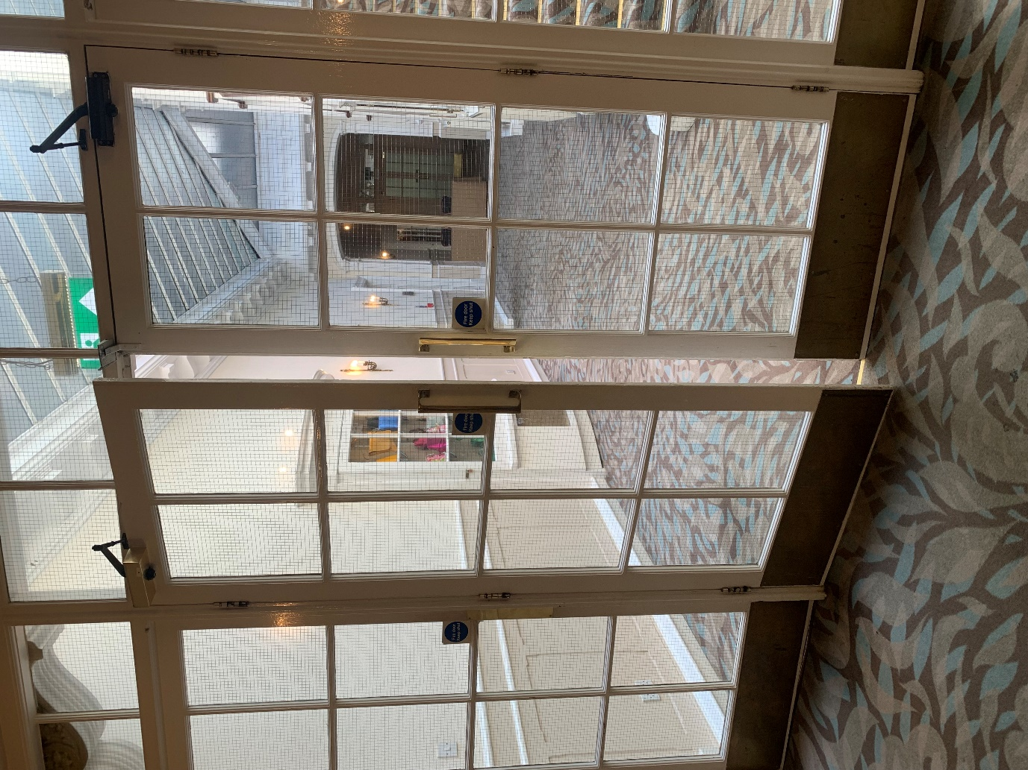
Once you have entered the lobby, as you approach the lift, if you turn left, you’ll see this corridor which leads to the Ballroom and the Garden Room.
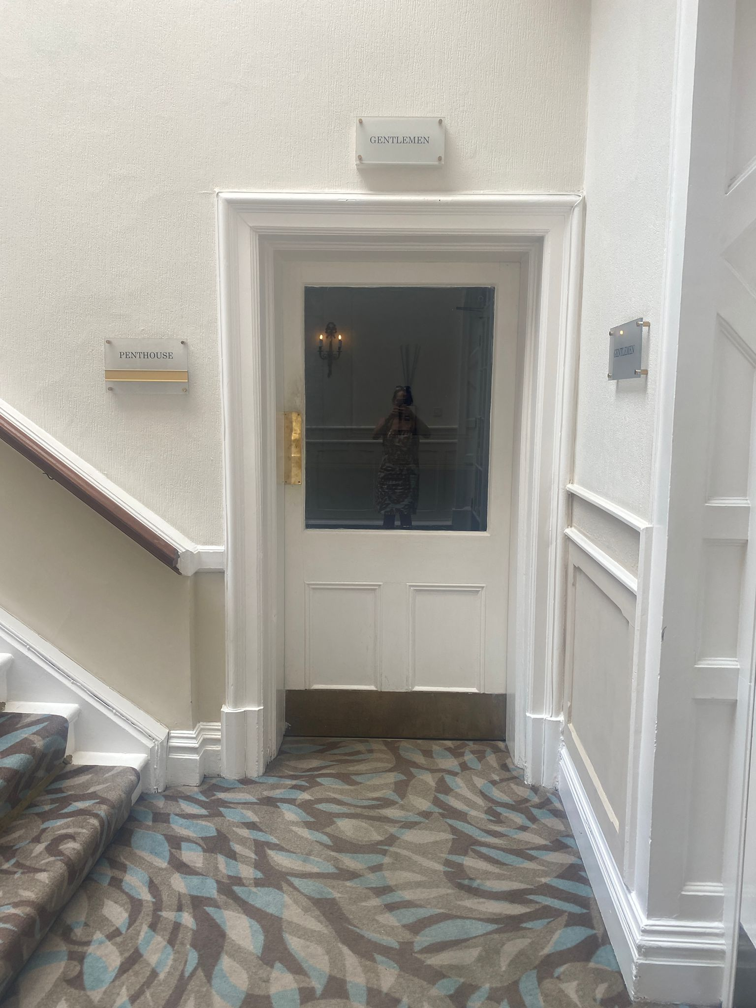
The Gentleman’s toilets are the first door on the right along this corridor.

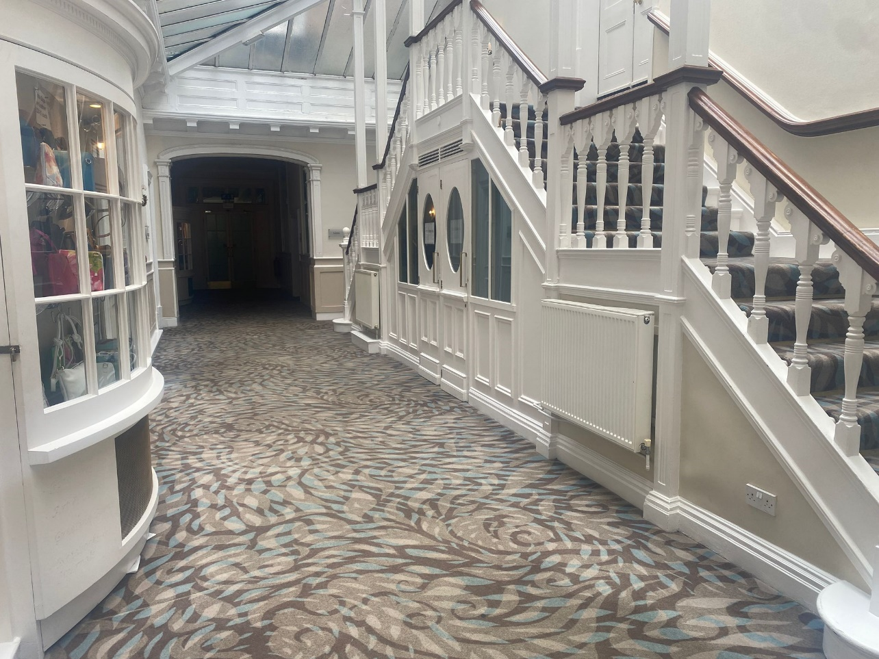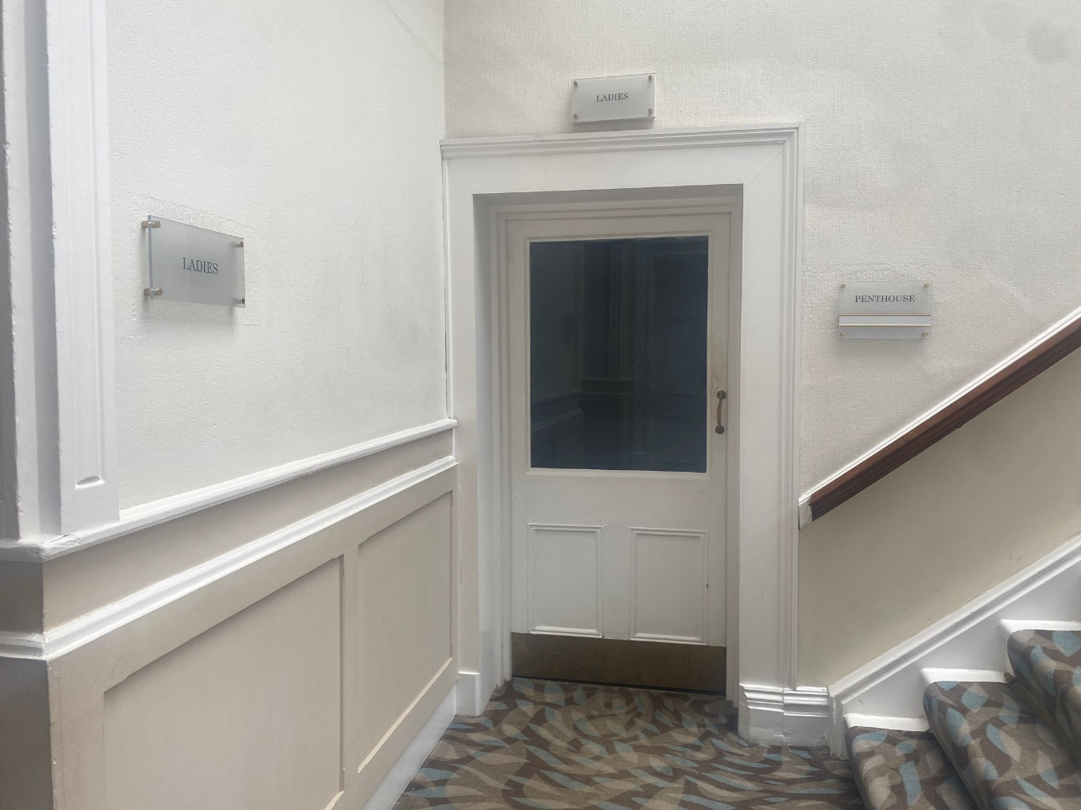

The ladies are on the right just pass the staircase.

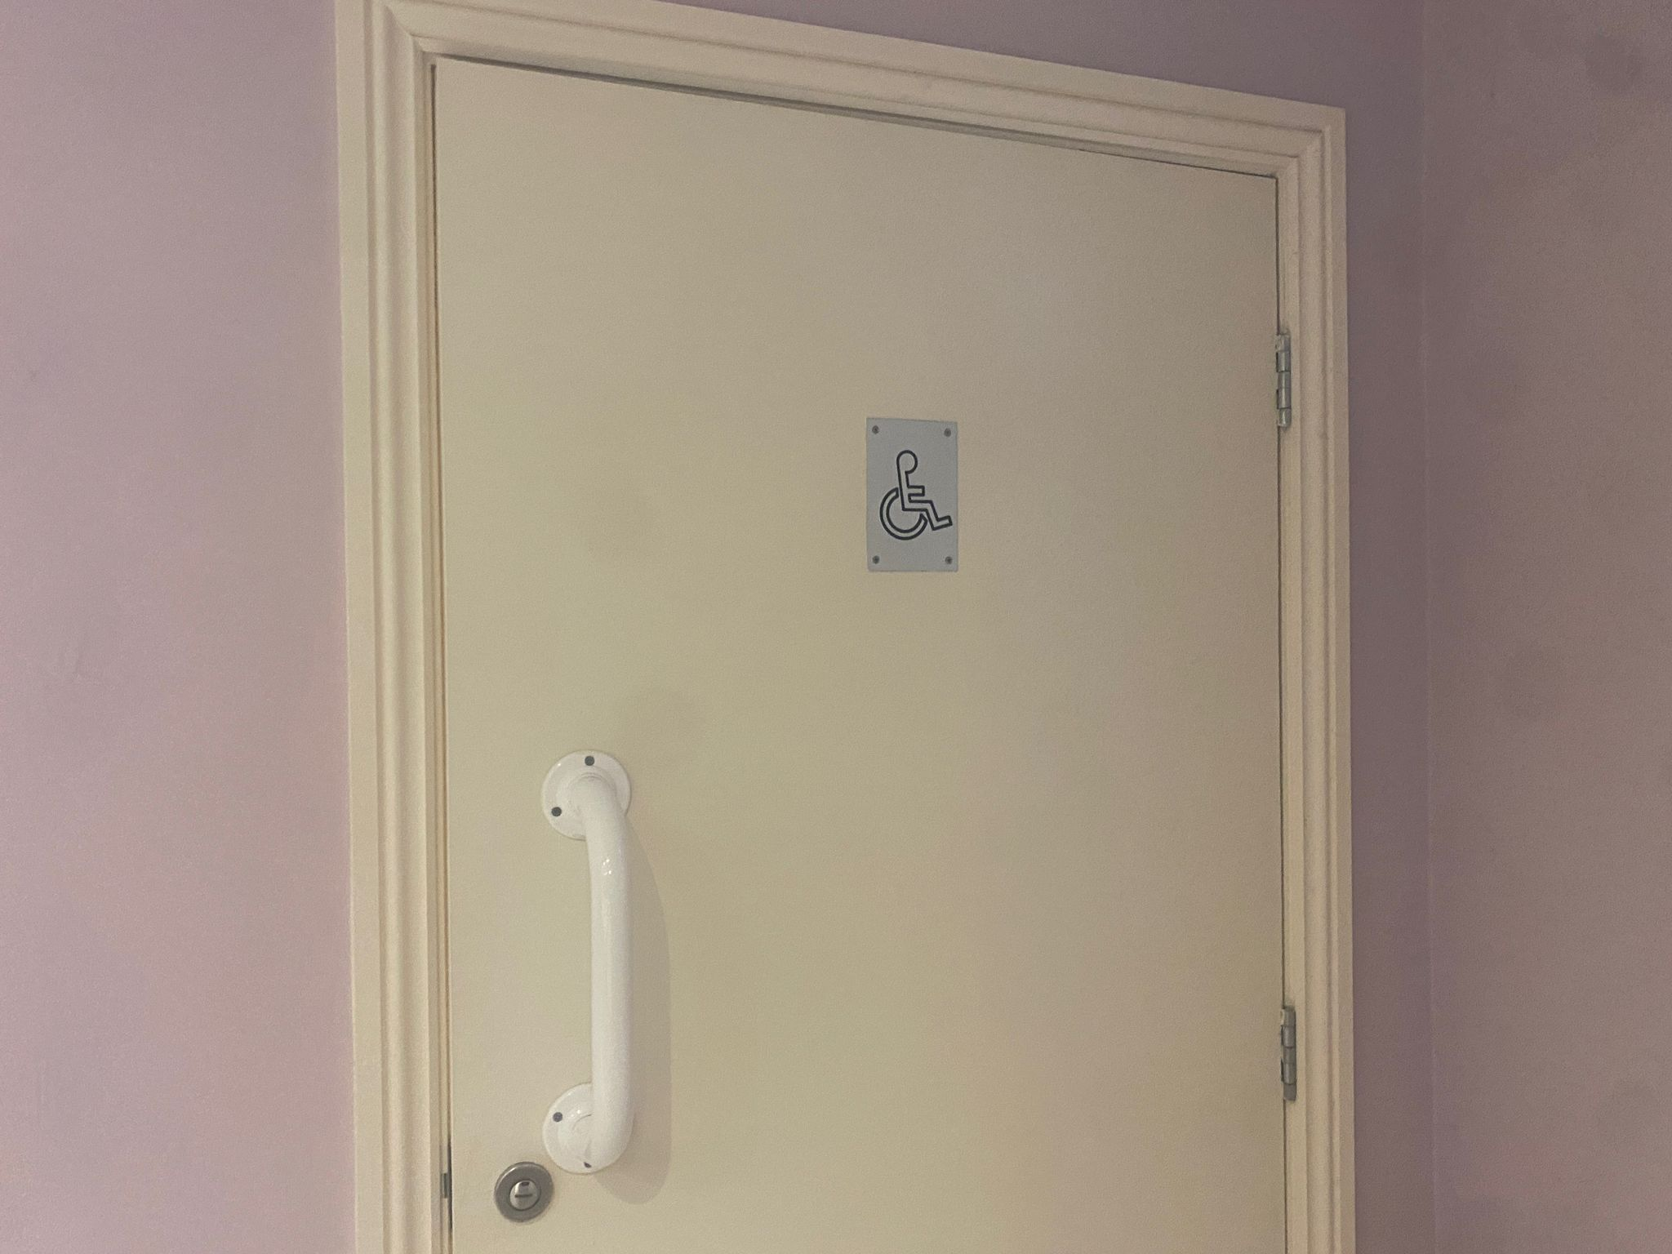
The accessible toilet can be accessed without a RADAR NKS key. Below the handle will have a red slot to indicate if the toilet is already engaged.
For Theakston Old Peculier Crime Writing Festival, there will be additional toilet facilities around the site which will be indicated on a site map found at the venue.
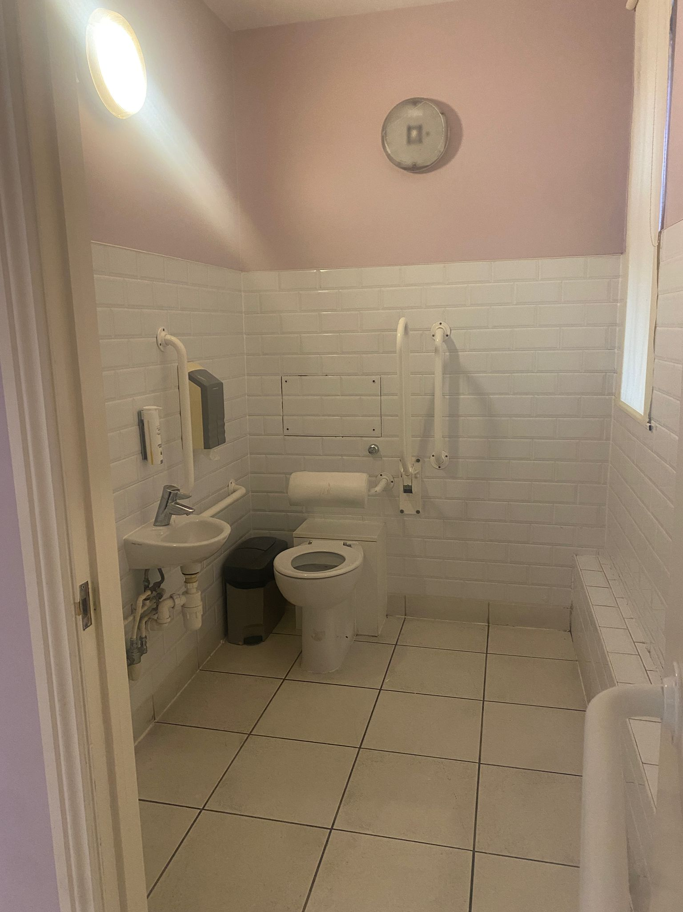
This accessible toilet is fitted with handrails beside the toilet, sink and door.

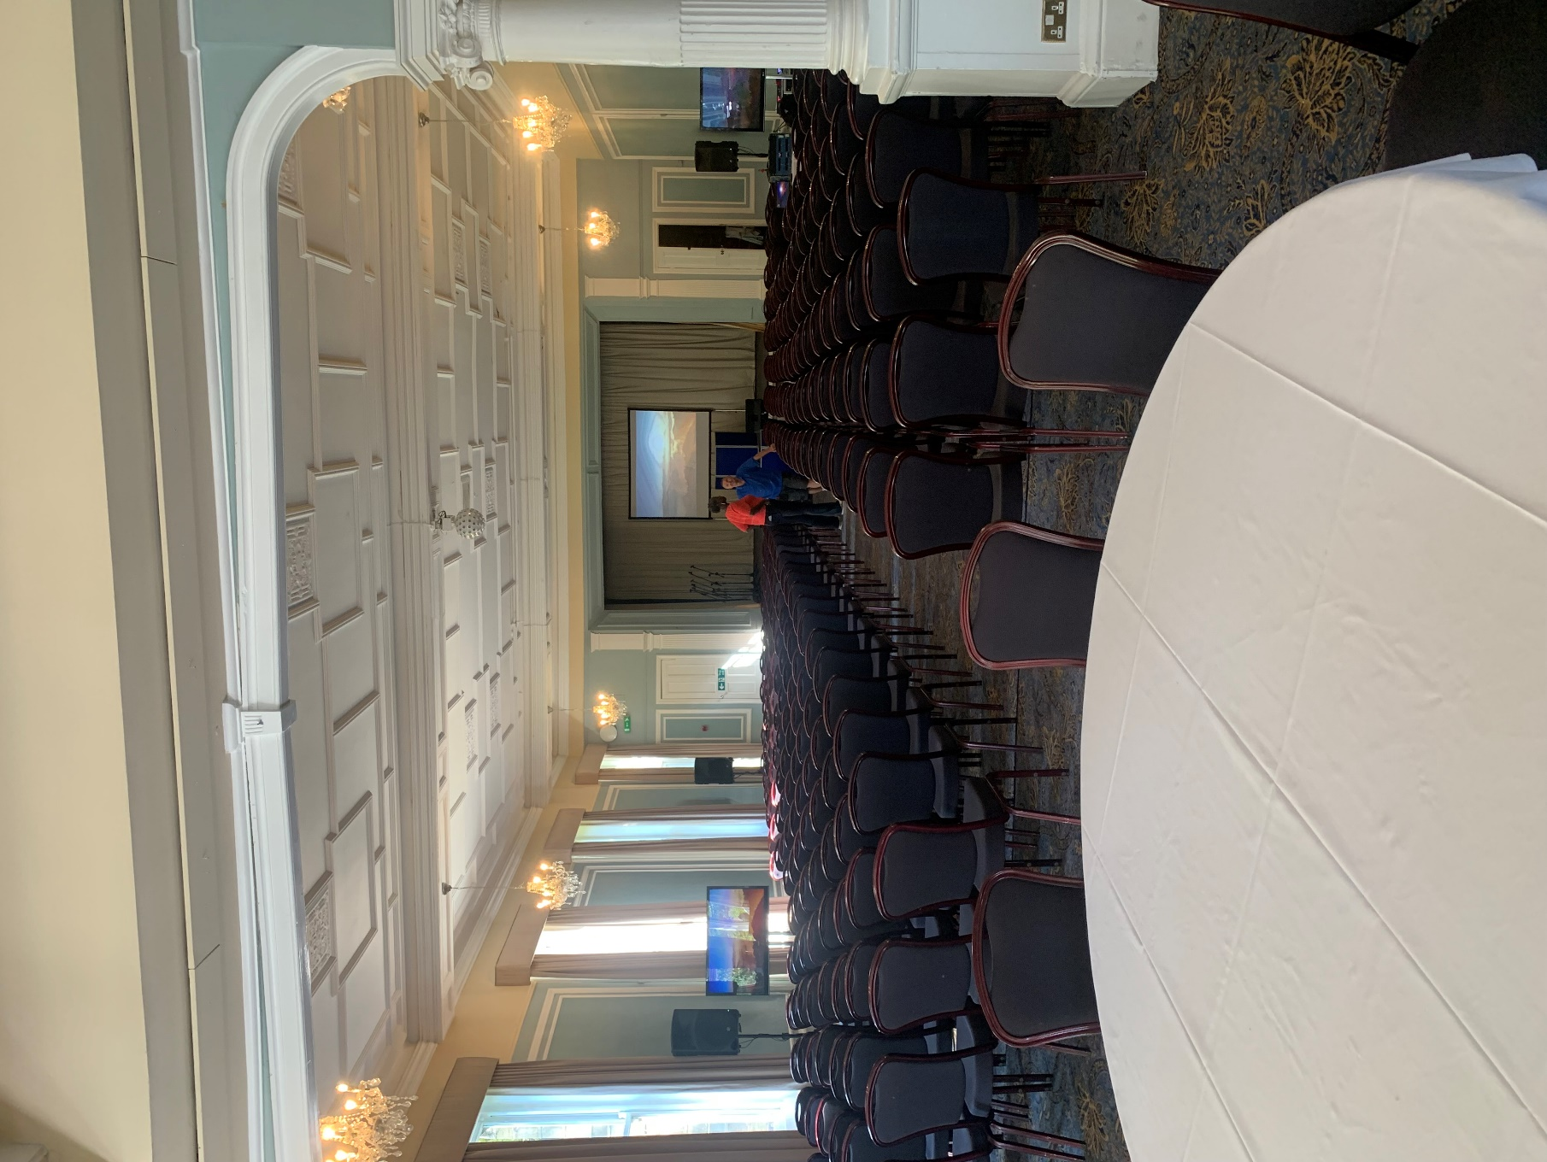
For Harrogate International Sunday Series, events take place in the Ballroom and the Garden Room will be laid out in theatre style rows.

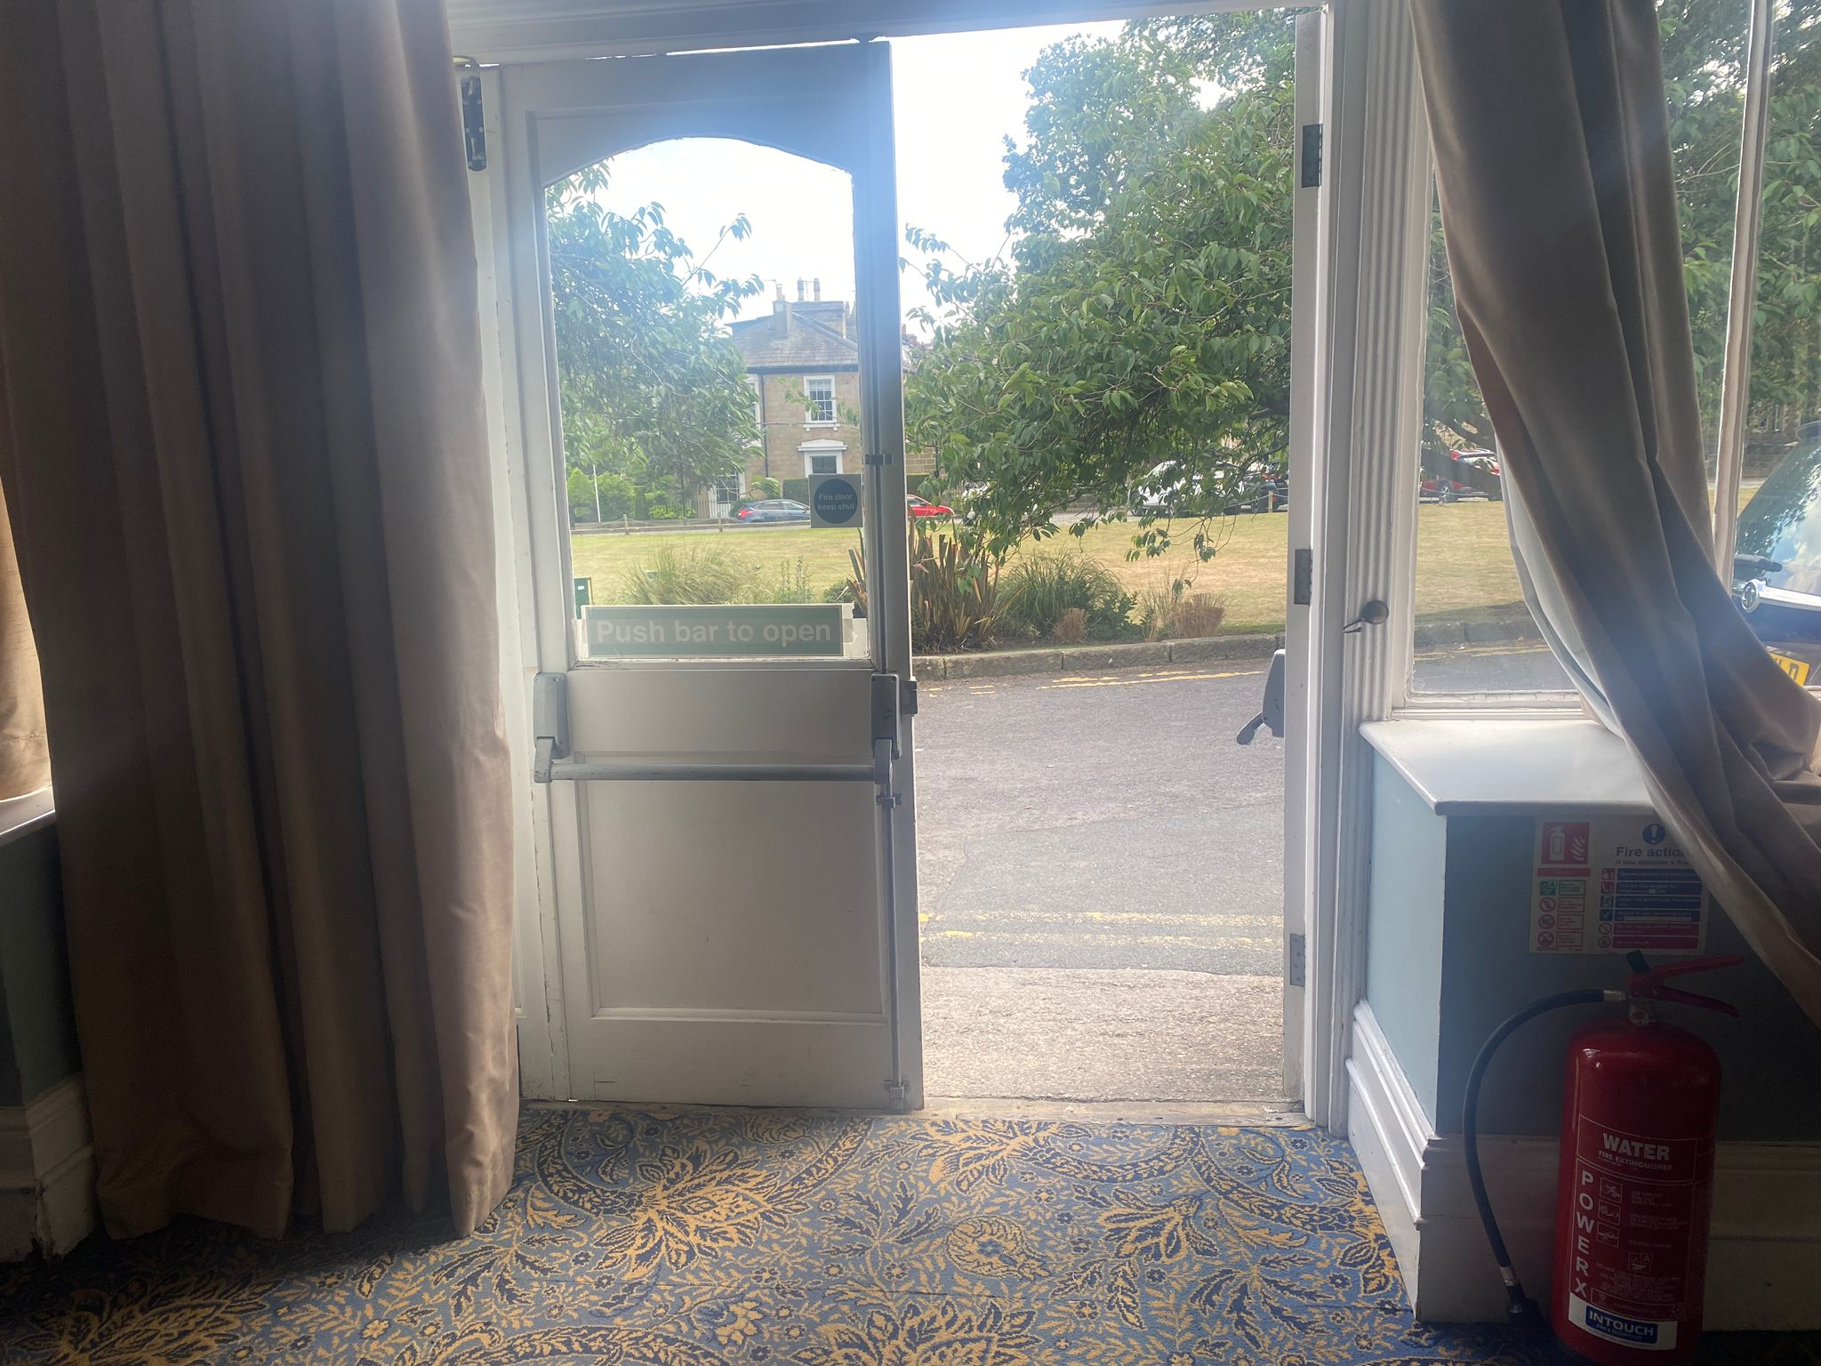

At the rear of the Garden Room is an exit with a ramp. Dependent on the event, this is also used as an entrance.

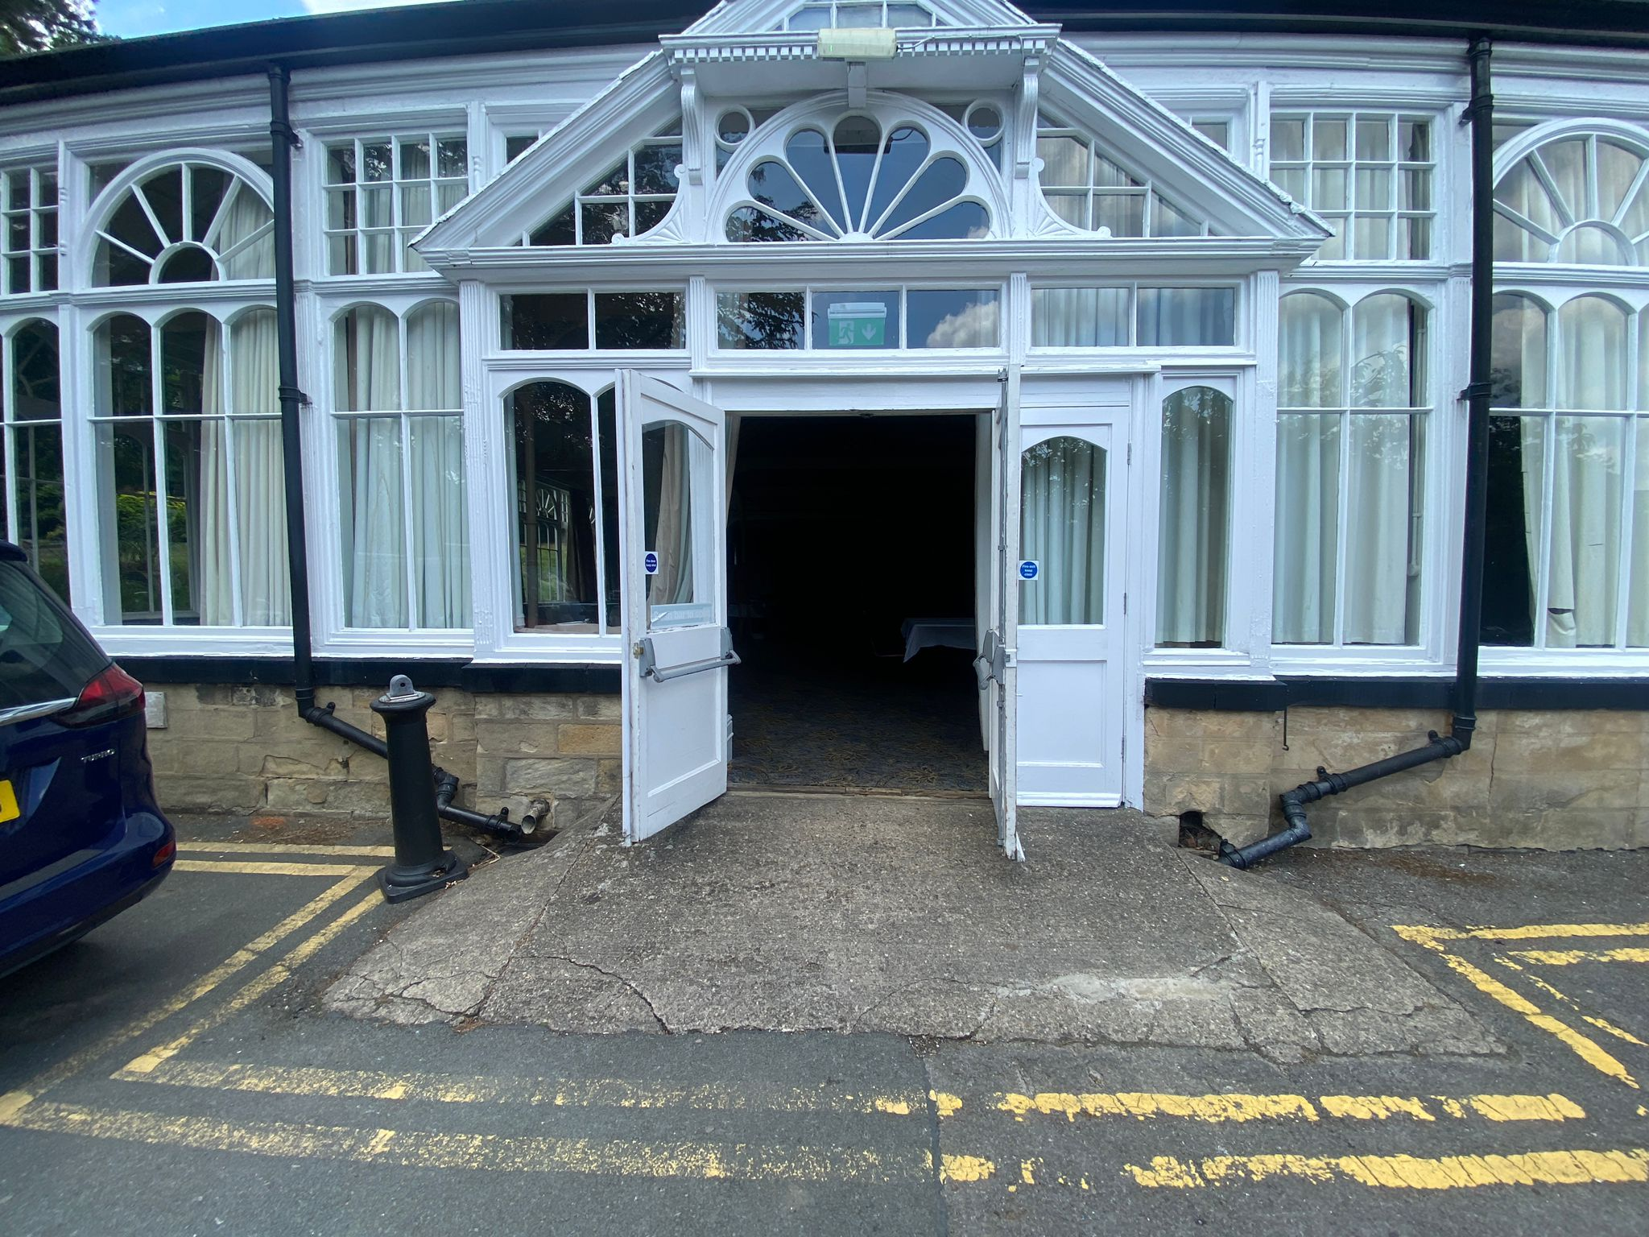

For example, for Theakston Old Peculier Crime Writing Festival uses this space as a bookshop which can be accessed using these doors or the hotel’s main entrance.
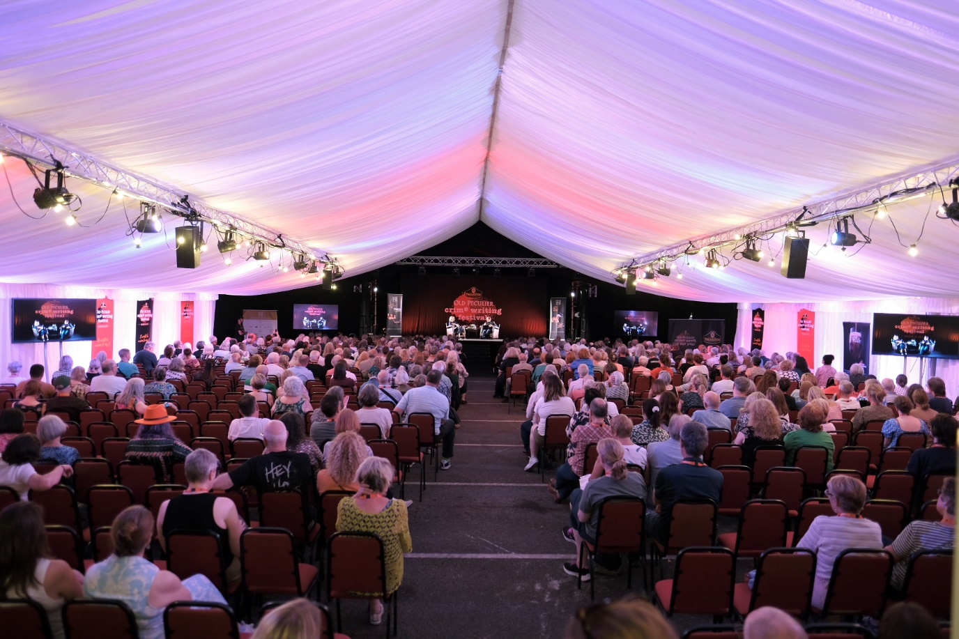

For the Theakston Old Peculier Crime Writing Festival, the main stage events take place in the main event tent, which is up an incline round to the left of the hotel. Please notify Box Office ahead of time if you require a wheelchair accessible seat or any other adjustments.
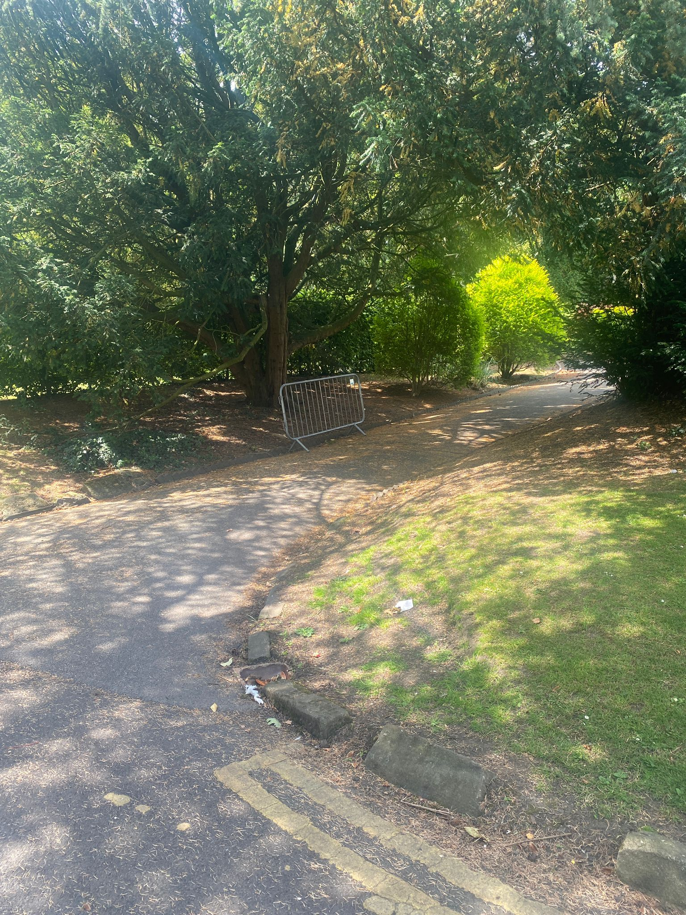
For Theakston Old Peculier Crime Writing Festival, there is a specific pathway used to access the main event tent. This path is only to be used by members of our access scheme and Friends of the Festival to access the main event tent but please note the events may be happening on the route. This path is to the left of the ballroom.

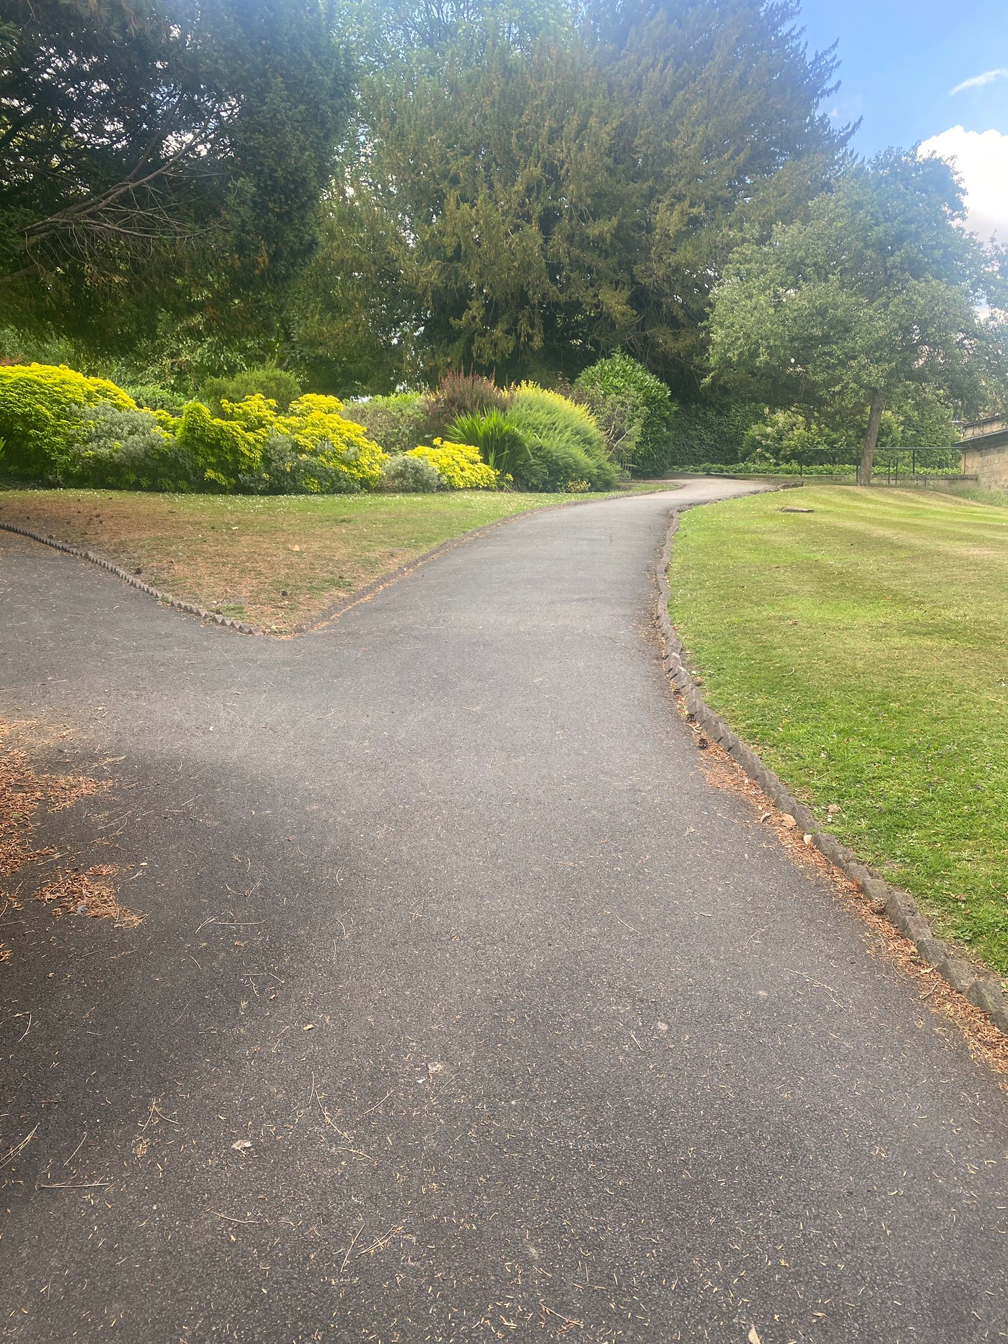

This pathway diverges into two and to reach the main event tent, you must use the right hand pathway. Other events and activities may be occurring along the left hand pathway.

